# 6. User Interface Design

## 6.1 Login Page

The Login page of the website allows login for both super authenticated user as well as regular authenticated user. User must enter a valid username and password to get access to the system as shown below

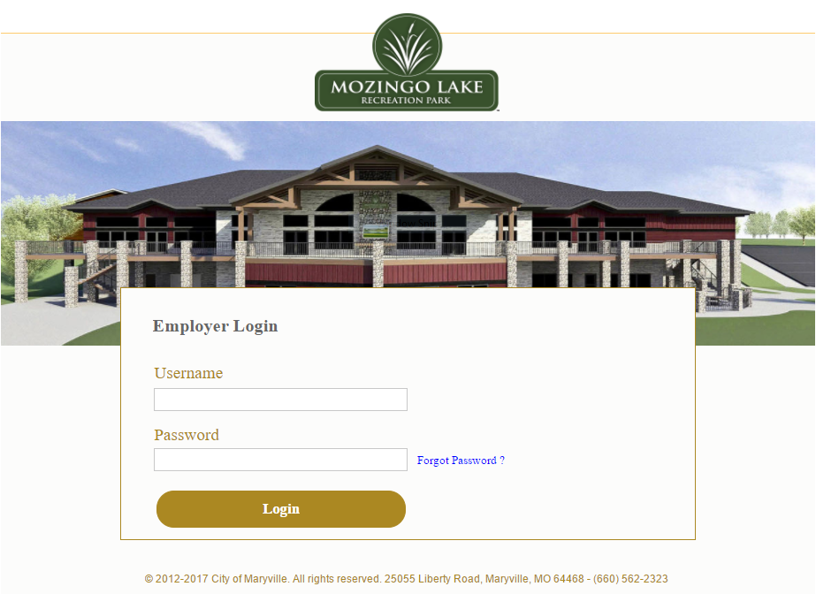

**Figure L1: Login Page**

If user enters incorrect credentials, a warning message is displayed, and the user is asked to re-enter valid credentials. The Login page also includes forgot password link which can be clicked when the user forgets the login password.

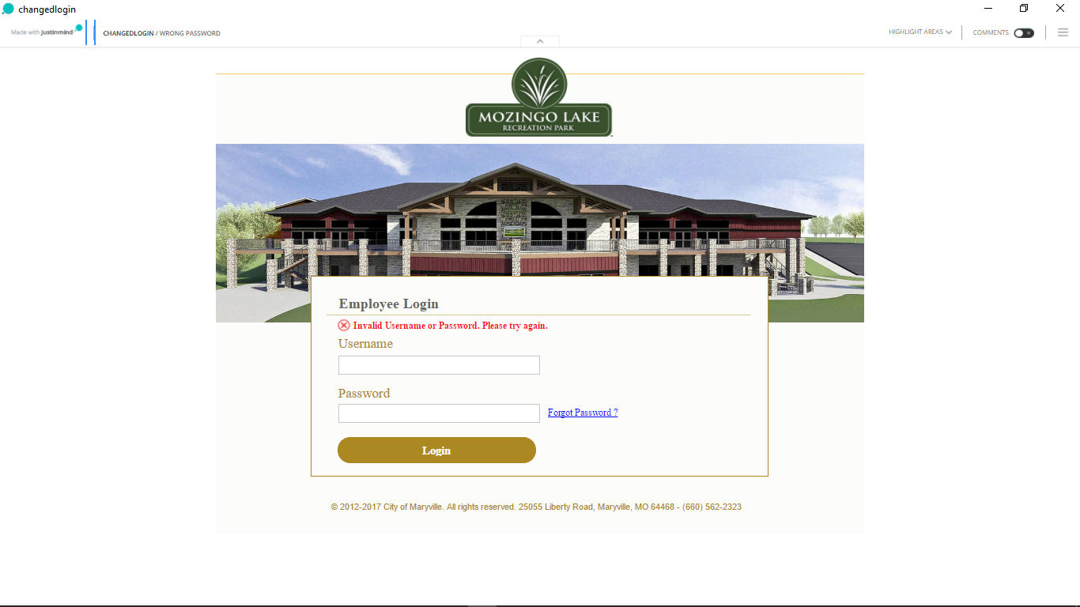

**Figure L2: Invalid Credentials**

## 6.2 Forgot Password Page

When User clicks on forgot password a new page appears where the user is asked to renter the username and click on submit to receive a password reset link to the registered email id.

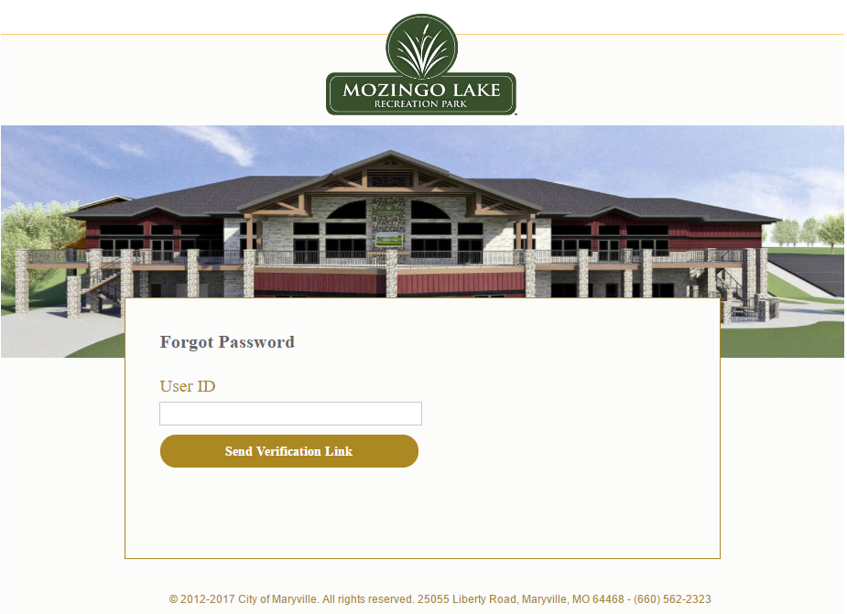

**Figure F1: Forgot Password**

When User enters the correct username, a message is displayed which states that the password reset link has been sent to the registered email id of the user from where the password can be reset. User can also request to resend the link if the link does not appear in user email.

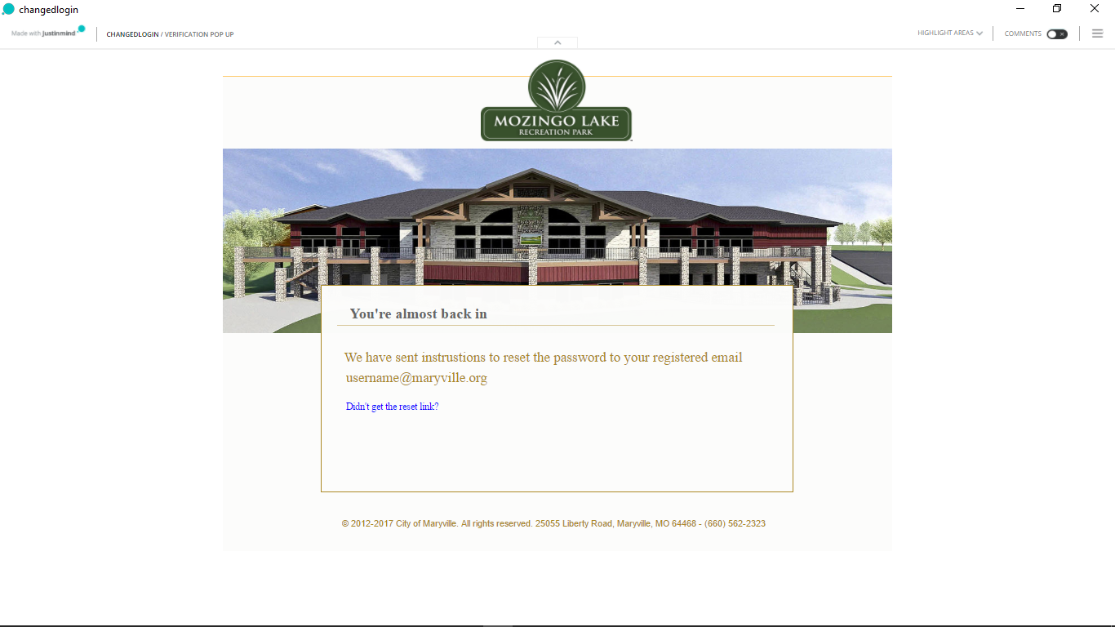

**Figure F2: Reset Link Sent**

When User clicks on the password reset link sent to the registered email id, user is redirected to the password reset page where username is mentioned, and the user is asked to enter a new password and confirm the same. If the new password entered does not matches with the confirm password, then the label “Password Match” is displayed as “No”.

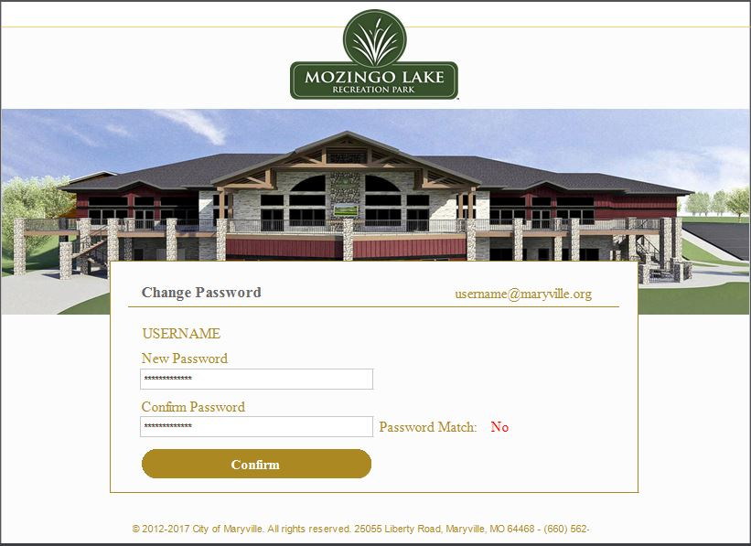

**Figure F3: Password Mismatch**

If the new password entered matches with the confirm password, then the “Password Match” is displayed as “Yes”.

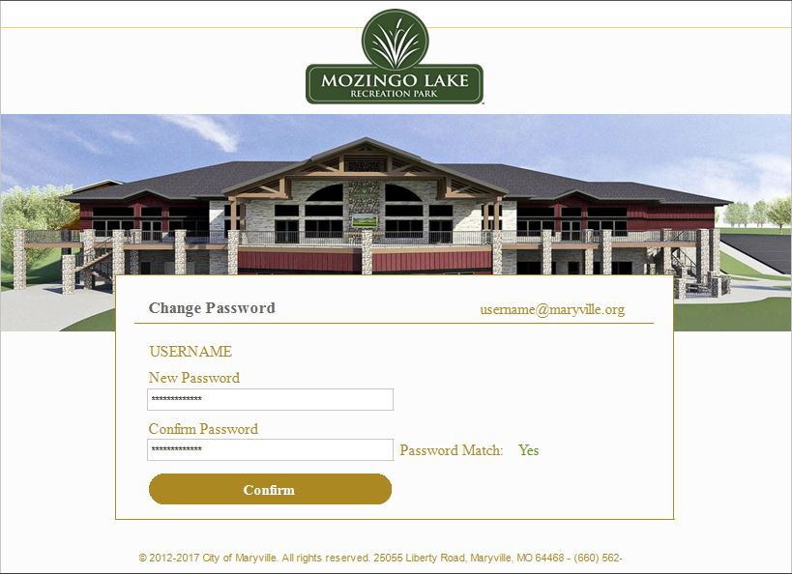

**Figure F4: Password Match**

When User confirms the new password, a message is displayed which confirms that the password has been successfully changed. User can now click on continue to go the Home page of the system.

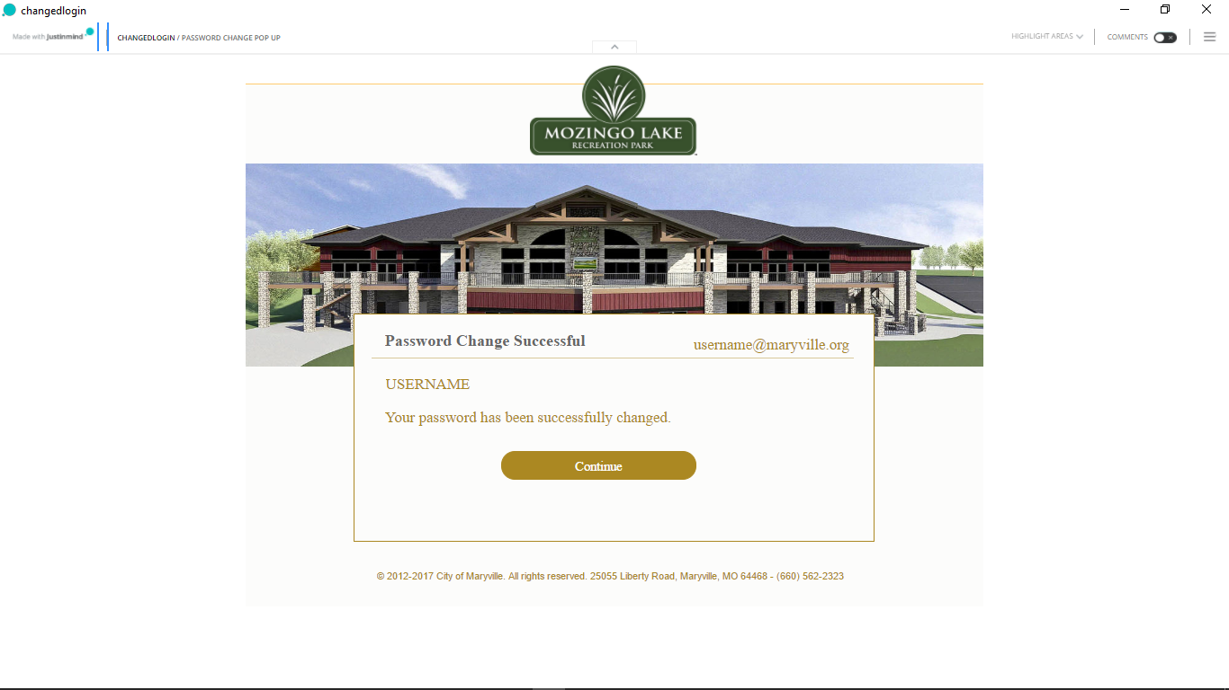

**Figure F5: Password change confirmation message**

## 6.3 Home Page

### 6.3.1 Authenticated Super User Home

When Super user logs in to the system, all the four systems are listed and super user can get into the preferred system by simply clicking on the system. This page is visible only to super user.

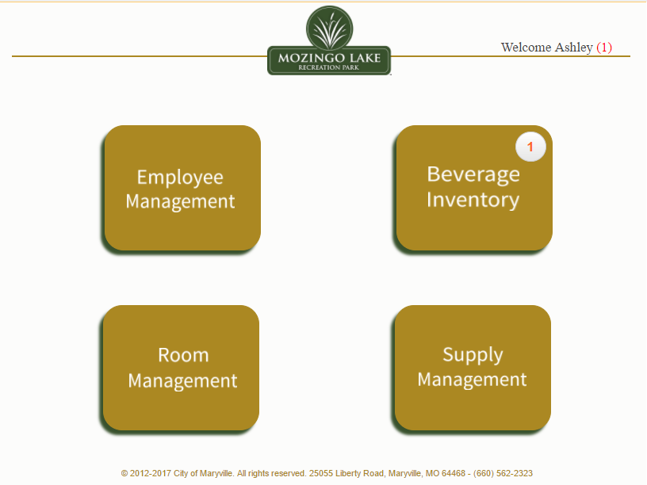

**Figure ASU1: Home Screen**

When Super User hovers to the username (Welcome Ashley) on the top right of the screen as shown below, he/she can access the System Notifications, My Profile and Admin Panel by selecting from the dropdown list. The super user can also logout from the system by selecting the Log Out option from the dropdown list.

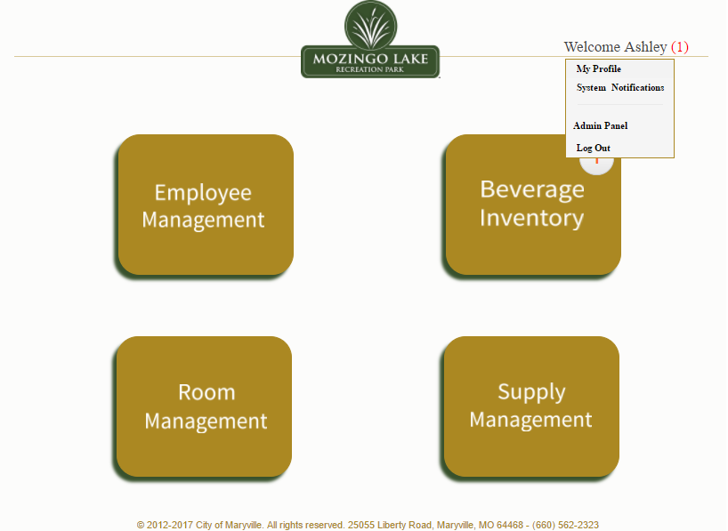

**Figure ASU2: Home Screen Options**

Super User can select the My Profile option from the dropdown list by hovering to the Username. This directs the Super User to their profile where they can view or Edit details such as Name, E-mail ID, Phone Number and Address.

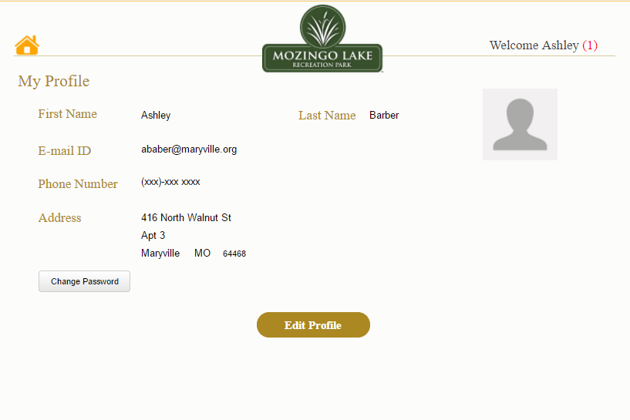

**Figure ASU3: View Profile**

Once super user clicks on the edit profile button, he/she can then edit their Profile details. Note that E-mail ID cannot be changed or edited as it is system generated.

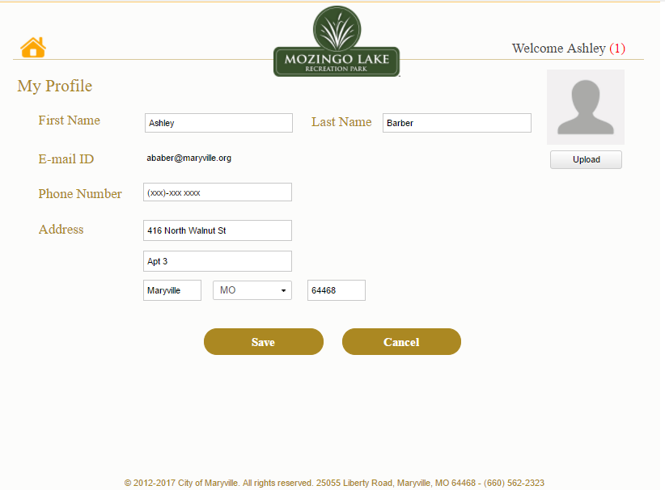

**Figure ASU4: Edit Profile**

As shown in the image below, a user consent appears when the super user clicks on the cancel button to cancel the changes made. System redirects to My Profile page when super user clicks ‘Yes’ on the user consent or is redirected to the same page where he/she can edit details when the user clicks ‘No’.

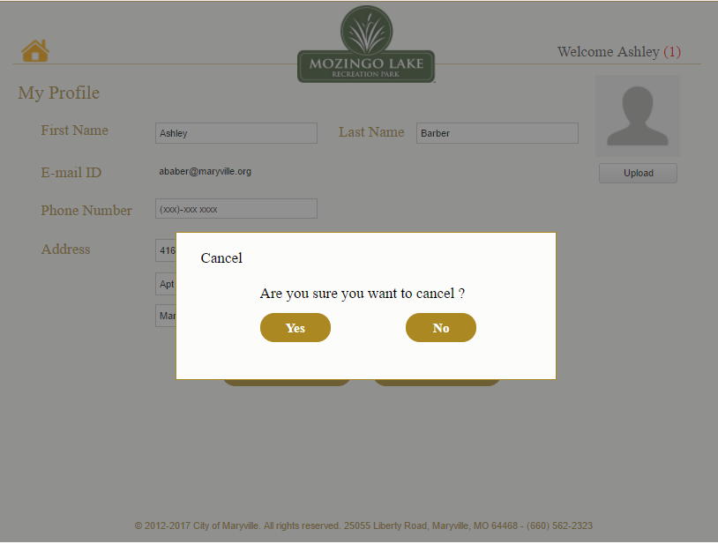

**Figure ASU5: Cancel profile edit**

When super user clicks on the save button to save the changes made, a user consent appears asking whether the user wants to save the changes or not.

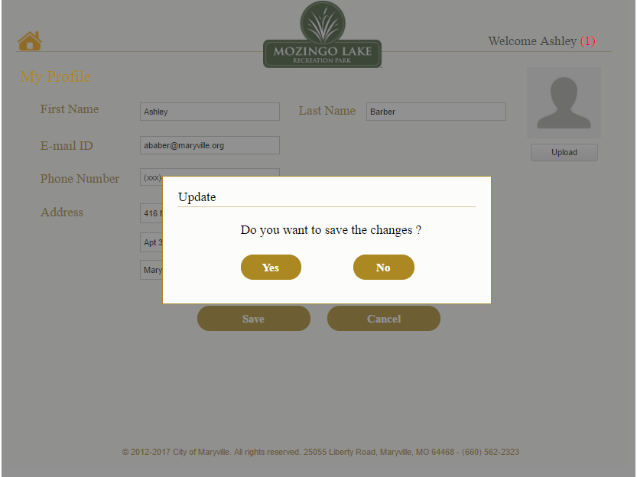

**Figure ASU6: Update Profile**

Current password can be changed by super user by simply clicking on the change password button in My Profile Page. Super User will then have to enter the old password and the new password will be entered in two fields i.e., New Password and Confirm Password for them to match.

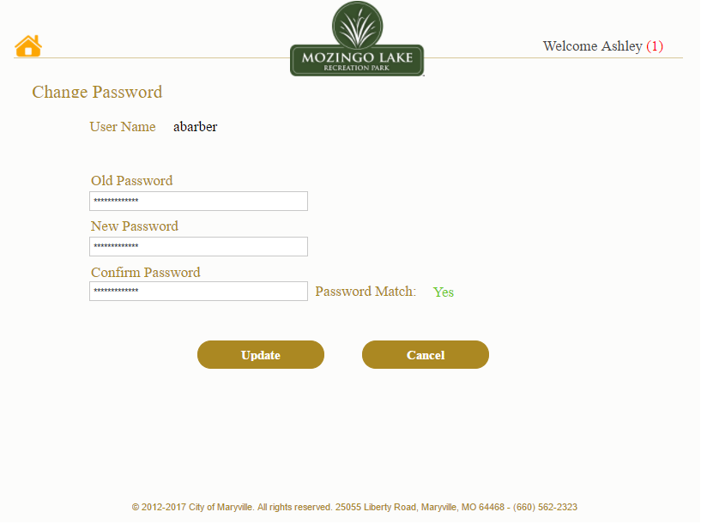

**Figure ASU7: Change Password**

The process of changing password can be cancelled by clicking on the cancel button. User consent appears when the user clicks on cancel button.

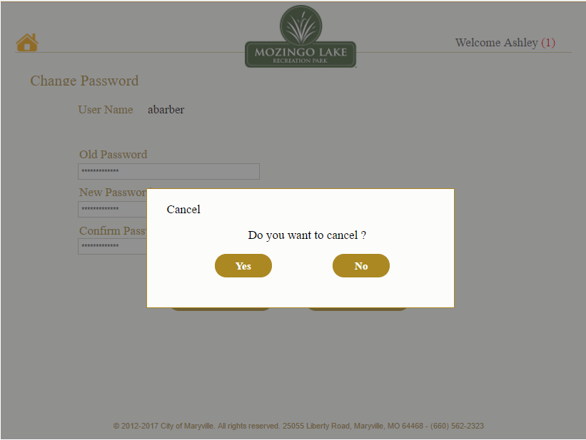

**Figure ASU8: Cancel Changes**

When the user clicks on the update button, User consent appears asking whether the user wants to update the password or not.

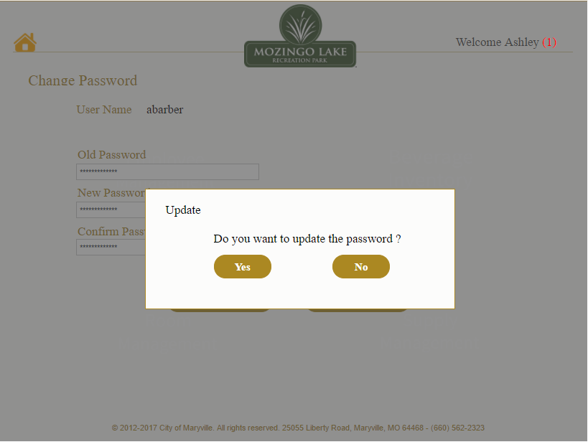

**Figure ASU9: Update Password**

Super user is notified when the password is successfully changed as shown in the image given below.

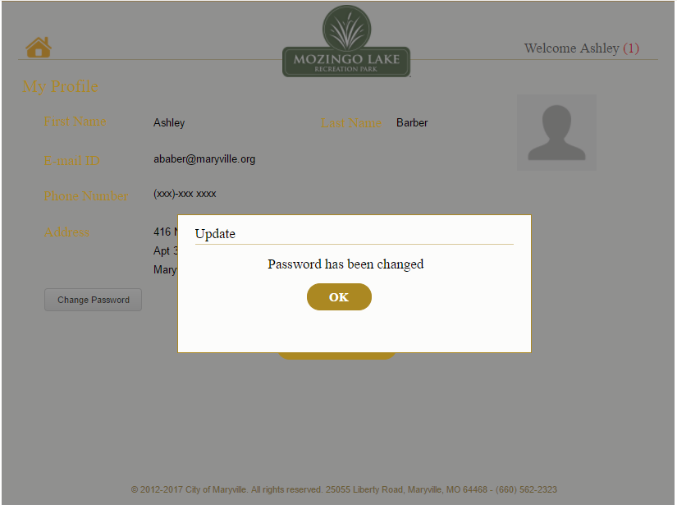

**Figure ASU10: Password Updated**

By clicking on the admin panel option from the dropdown list, the super user is directed to the admin panel where a new user can be added, and the Super user can view all the active and inactive employees as shown below. The super user can also make a user inactive by clicking the inactive button next to the username.

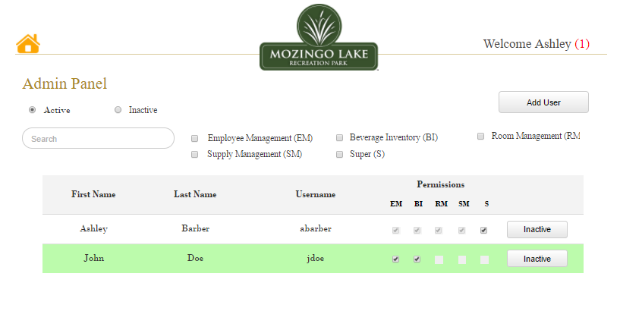

**Figure ASU11: Admin Panel**

To add a new user, super user will first have to click on the Add user button in the Admin Panel and then enter the details related to the user and give permission to different systems which the user will then have access to.

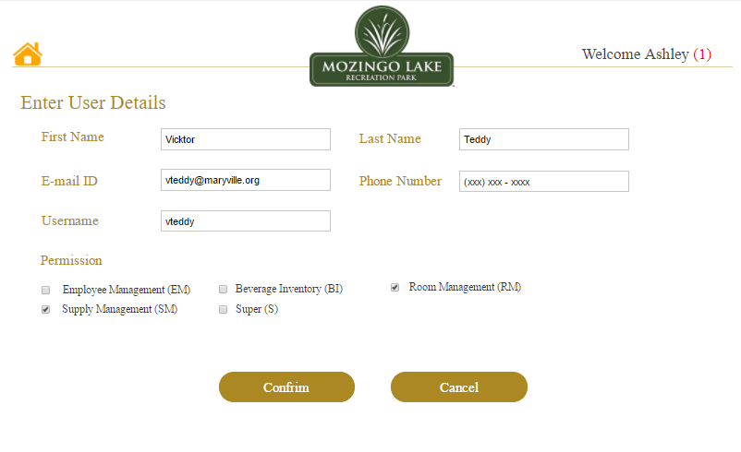

**Figure ASU12: Add User**

If super user needs to go back or doesn’t not want to add user, he/she can click on the cancel button. A user consent appears asking for confirmation. After clicking yes, system is redirected to the previous page and if user clicks no, it remains on the same page.

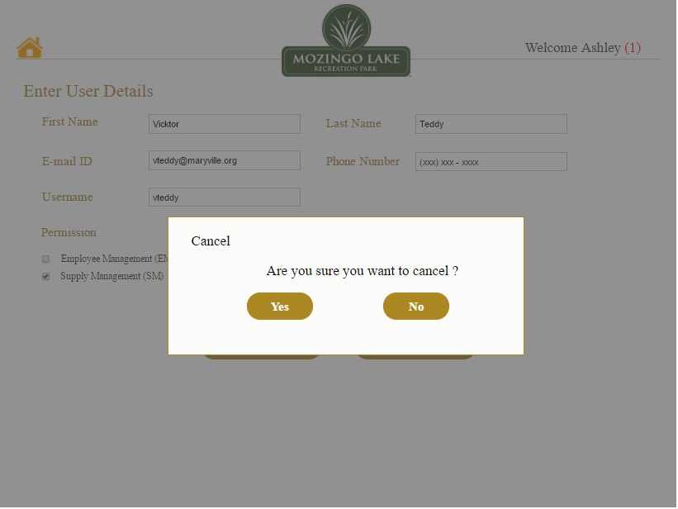

**Figure ASU13: Cancel Add User**

Once super user is done adding the new user and is ready to save/update the details, he/she clicks on the confirm button. a user consent appears as shown below.

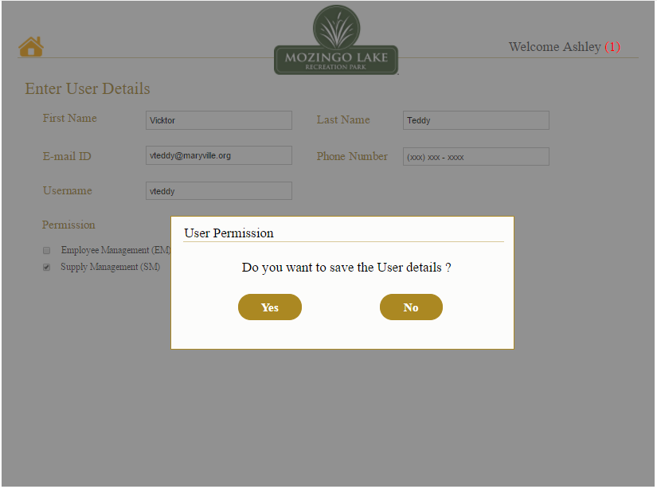

**Figure ASU14: Save User details**

When Super User clicks “yes” on the user consent asking to save details, all the details related to the new user are saved and updated in the list of active users as shown below. Vicktor is the new user that has been added by super user.

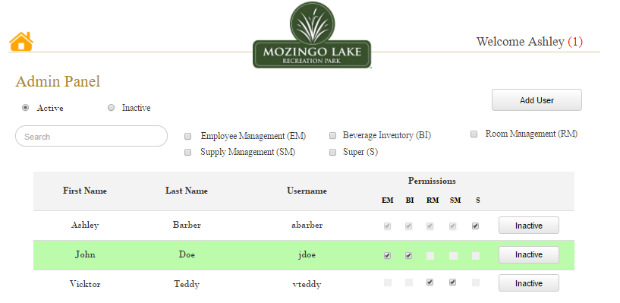

**Figure ASU15: Updated List of Active Users**

Once the User is added to the system the below page will be displayed and Super user can click on the users name to view or edit the information. When the Super User clicks on the “Edit” button he will be able to edit the user details and permissions for that particular user.

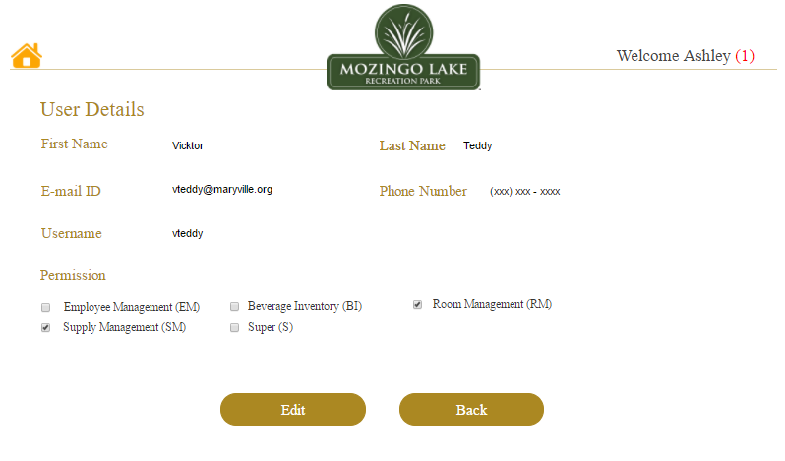

**Figure ASU16: Edit User Details (Admin Panel)**

After Super User clicks on the “Edit” button he will be able to edit the user details on this page. He can either click on the “Update” button if he/she is done making the changes or can click on “Cancel” button if he/she doesn’t wish to make any changes.

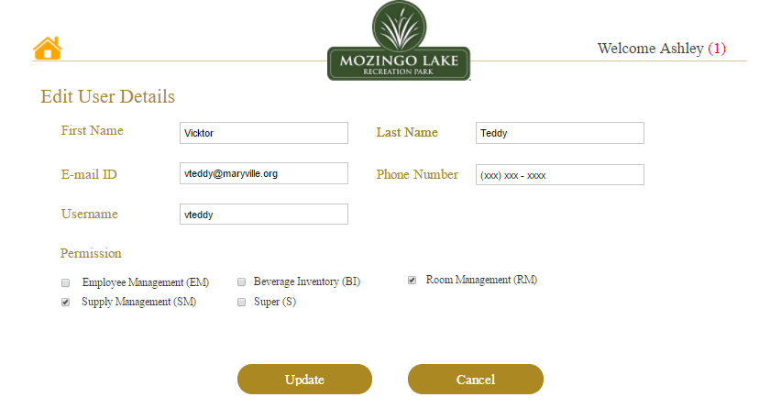

**Figure ASU17: User Details Edit Page**

After the Super User Edits the User information, he/she can apply the changes by clicking on the “Update” button. When the User clicks on the “Update” button, a dialog box appears on the screen which displays a message asking if the User wants to save the changes or not. Once the User clicks on ‘Yes’ the Changes will be saved and if the User clicks on ‘No’ the changes will be discarded.

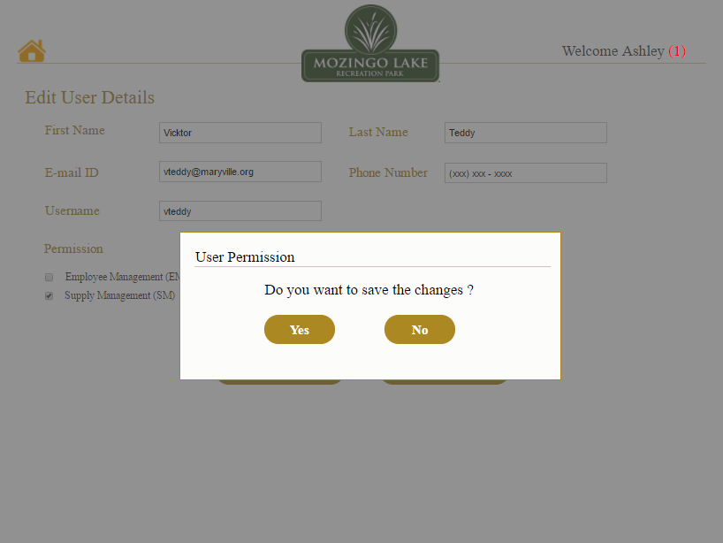

**Figure ASU 18: Update Changes (Edit User Details Page)**

Once the Super User edits/makes any changes to the Users’ profile, the changes will be updated to the User profile and Super User will be directed to the Admin Panel page where he/she can view the list of active Users.

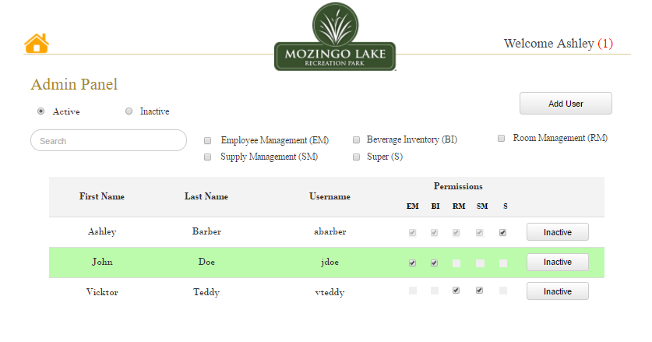

**Figure ASU19: Updated Admin Panel**

After editing the User Details, if the Super User doesn’t want to save the changes, he/she can click on the “Cancel” button. After he/she clicks on the cancel button, the below page will be displayed, and a dialog box will appear on the screen asking if he/she is sure to cancel the changes made. When the Super User clicks on ‘Yes’ he will be directed with to the Admin panel else, will remain on the same page.

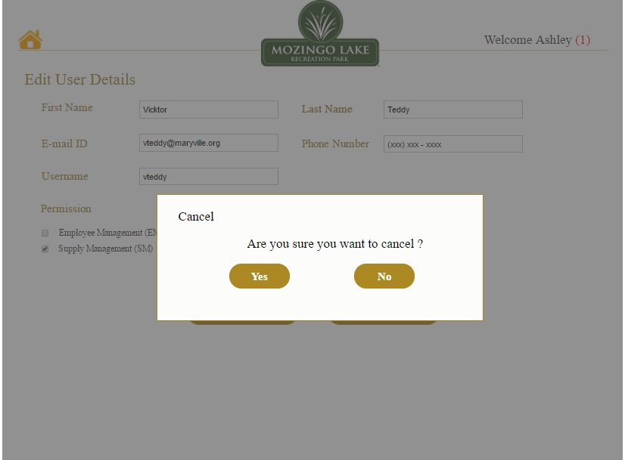

**Figure ASU20: Cancel Changes (Edit User Details Page)**

The Super User can view the list of Active and Inactive Users on the Admin Panel Page. He/She can make changes to the Users’ status, such as active/ inactive. To Inactivate a User from the system (Permissions to access the system are removed), the Super User can click on the “Inactivate” Button that is placed in the User details row. When the Super User clicks on the “Inactivate” button the below page will be displayed with a dialog box with a message asking if the user is sure to Inactivate the User. If he/she clicks on ‘Yes’ the user will be Inactivated, and the Users’ details will be removed from the Active list and will be updated automatically to the ‘Inactive’ list, else the Super User will remain on the same page and Users’ status will remain same.

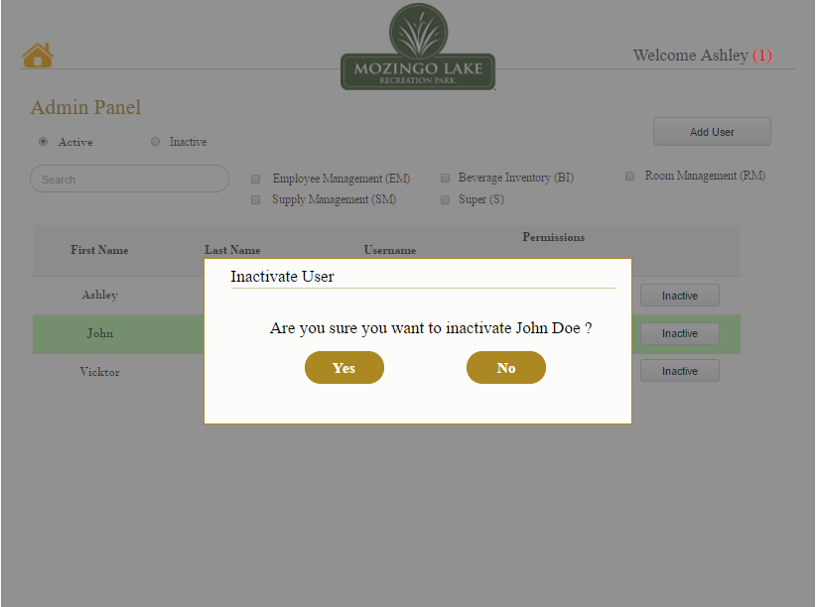

**Figure ASU21: Inactivate User**

After the User ‘John Doe’ is Inactivated, the below page will be displayed, showing the updated list of the ones that are active.

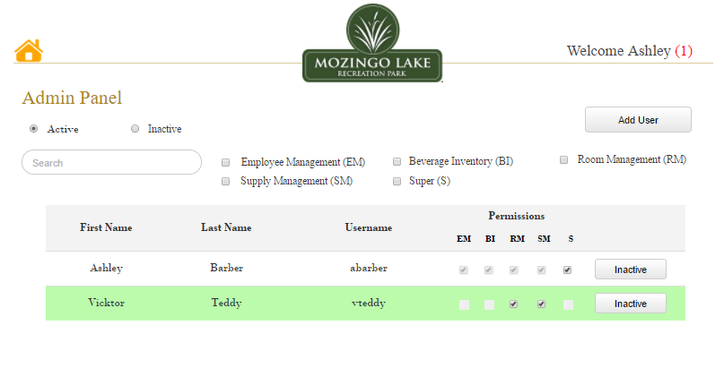

**Figure ASU22: Updated Active User List**

When Super User clicks on “Inactive” radio button, a list of Inactive Users appears on this page. This page displays the list of all the employees who have been denied access to one or more systems (when they move out of the company). These users can be given permission to access the system(s) in case they join back. This can be done by clicking on the Activate Button and by doing so, the user information will be updated to the Active List.

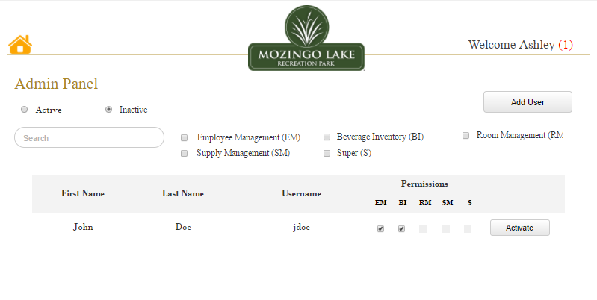

**Figure ASU23: List of Inactive Users**

Super User can look up for a User (In this case, Teddy) by entering their Username into the “Search Bar”

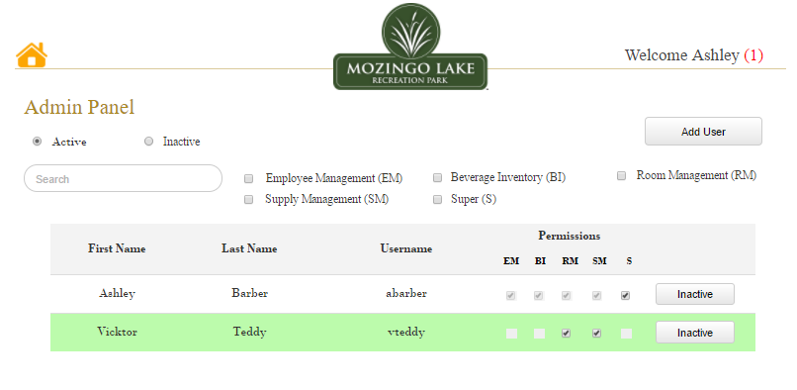

**Figure ASU24: Search Bar**

When the Super User searches for a User in the system using their Username/First Name/Last Name, the results will be displayed on this page and the Super User can either edit or revoke the permissions to access the system.

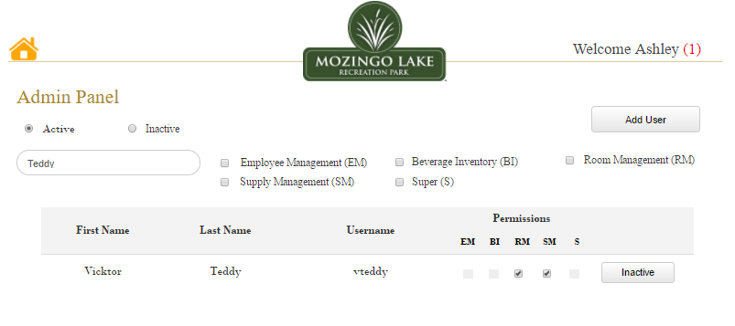

**Figure ASU25: Search Results**

After the search results are updated, Super User can click on the First Name/Last Name/Username which will direct him to that particular User details page or Super User can change normal user permissions to access the system(s).

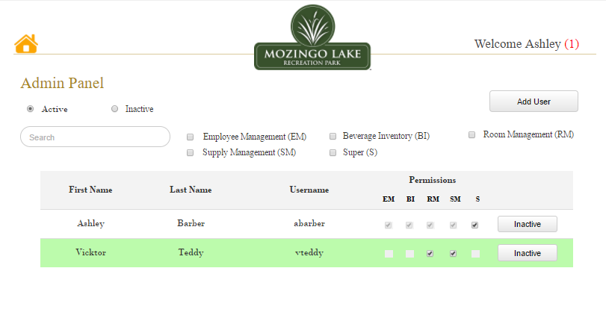

**Figure ASU26: Search Update**

On the home page we see that whenever there is a new system notification, it will be displayed in brackets next to the “Welcome Username Tab” on the top right corner of the screen. These notifications are generated when Super user makes any changes to the system, such as Adding a User, inactivating a User or adding a Super User. When we hover on the “Welcome Username Tab” we can click on the notifications option from the dropdown to view new notifications. “Green Dot” symbol next to a Notification represent the ‘Unread Notifications’

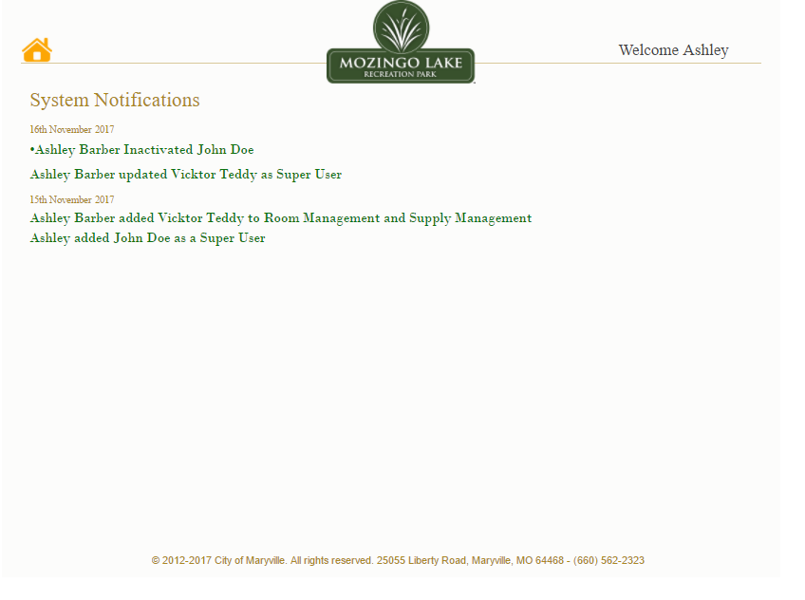

**Figure ASU27: Notification Page**

Once all the System Notifications are read, Super User can click on the “Home Button” which will direct him to the page displayed below. Since there are no pending System Notifications to be read, the notifications icon is no longer visible.

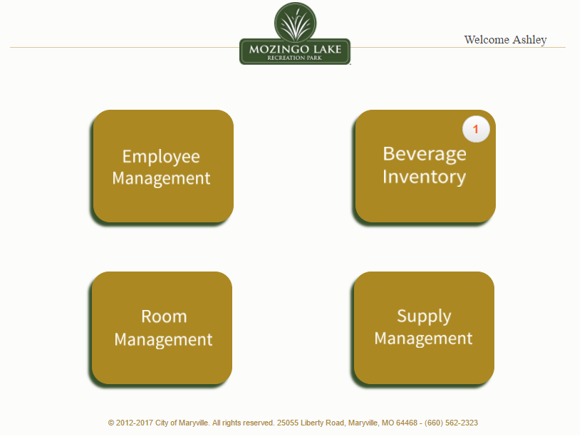

**Figure ASU28: Home Page after the Notification is read**

### 6.3.2 Authenticated User Home

This is the home page of a normal user (Vicktor Teddy is the normal user in this case). A normal user can only access those systems to which he is granted access. In the below screen, the user is permitted to use only the Employee Management and Beverage Inventory systems. The other systems are grayed (not accessible). The user can also see the notifications, if any. The screen below shows a notification for Beverage Inventory System.

A close up of a device

Description generated with very high confidence

**Figure AU1: Normal User Homepage**

When the user clicks on the username (“Welcome Vicktor”) on the top-right of the screen, then they will be provided with options to logout and go to his profile page (“My Profile”).

A screenshot of a cell phone

Description generated with very high confidence

**Figure AU2: Normal User Options**

If the user clicks “My Profile”, they will be navigated to his profile page, where they can view his profile. The user can choose the “Edit Profile” option, if they want to edit.

A screenshot of a cell phone

Description generated with very high confidence

**Figure AU3: Normal User Profile**

When user clicks “Edit Profile” option, they can edit or change his phone number and address only. Their name (First Name and Last Name) and E-Mail ID are set by the admin and cannot be edited by a normal user. The normal user can also change password and upload a picture, by clicking on the “Upload” option under the profile image icon.

A screenshot of a cell phone

Description generated with very high confidence

**Figure AU4: Normal User Edit Details**

The user is prompted for confirmation to save changes. If the user clicks “Yes”, their profile gets updated and if the user clicks “No”, they will be navigated to the profile editing page.

A screenshot of a cell phone

Description generated with very high confidence

**Figure AU5: Save Changes Pop Up**

The below is the screen showing the updated profile of the user.

A screenshot of a cell phone

Description generated with very high confidence

**Figure AU6: Profile Details Updated**

If the user wishes to change his password, they can click on “Change Password” option in the Edit Profile page. The user will have to enter his old password along with his new desired password. After confirming the new password, the system will recheck the new password and will prompt “yes” if the passwords match, else “no”. The user should click on “Update” option to save his password.

A screenshot of a cell phone

Description generated with very high confidence

**Figure AU7: Password Change Request**

The user is prompted for confirmation to save changes. If the user clicks “Yes”, their profile gets updated and if the user clicks “No”, they will be navigated to the password editing page.

A screenshot of a cell phone

Description generated with high confidence

**Figure AU8: Password Change Pop Up**

The below is the screen showing that the password is updated.

A screenshot of a cell phone

Description generated with very high confidence

**Figure AU9: Password Changed Pop Up**

## 6.4 Dashboard Display

When user logs in and selects the Employee Management System (EMS) module, then they are redirected to the EMS Dashboard where the “Events” tab selected in default that has scheduled events displayed on a calendar and upcoming events displayed beside the calendar. User can also scroll through the calendar to view or create any future events or look at the past events. User can sort the calendar by day, week, month and year. A search bar is also provided to search for events by providing an input. The scheduled events are displayed in two color tags where green tag indicates that the event is completely scheduled (i.e. required number of employees are assigned to the event), and the blue tag indicates the schedule is partially complete (more employees are yet to be assigned and other actions are pending).

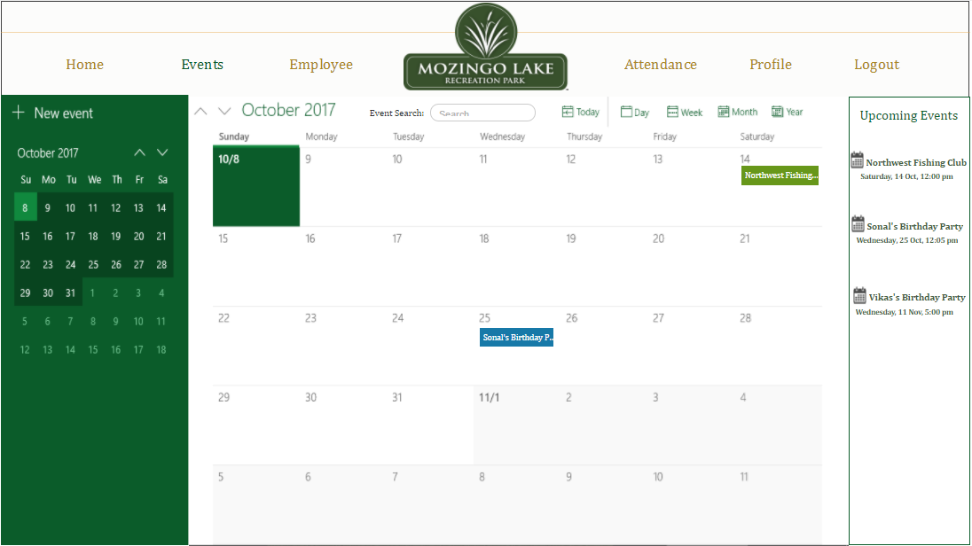

**Figure D1: Dashboard Display**

## 6.5 Events Tab

User can create a new event by clicking on the “New Event” from the dashboard. User will be redirected to a new screen to enter the details of the event such as Event Name, Location, Start Date, End Date and Time of the event to be scheduled.

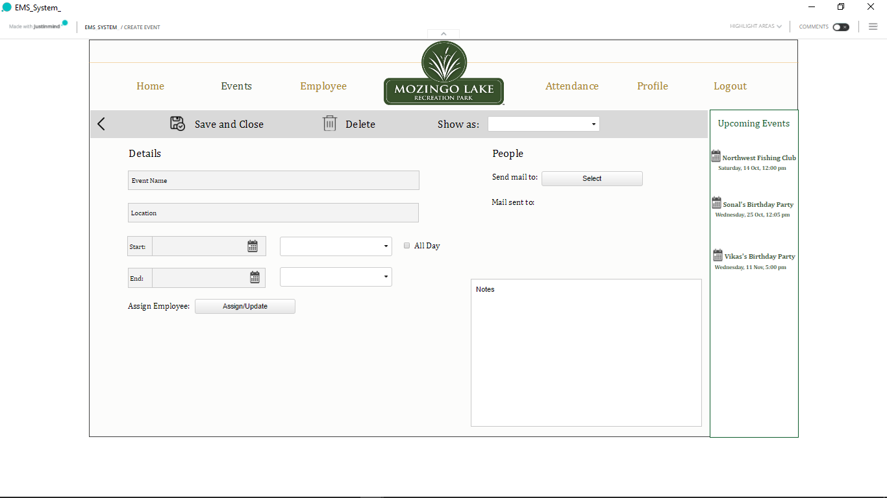

**Figure E1: Event creation**

When User clicks on the Start Date or End Date field/calendar icon, a calendar is displayed where User can select the required date.

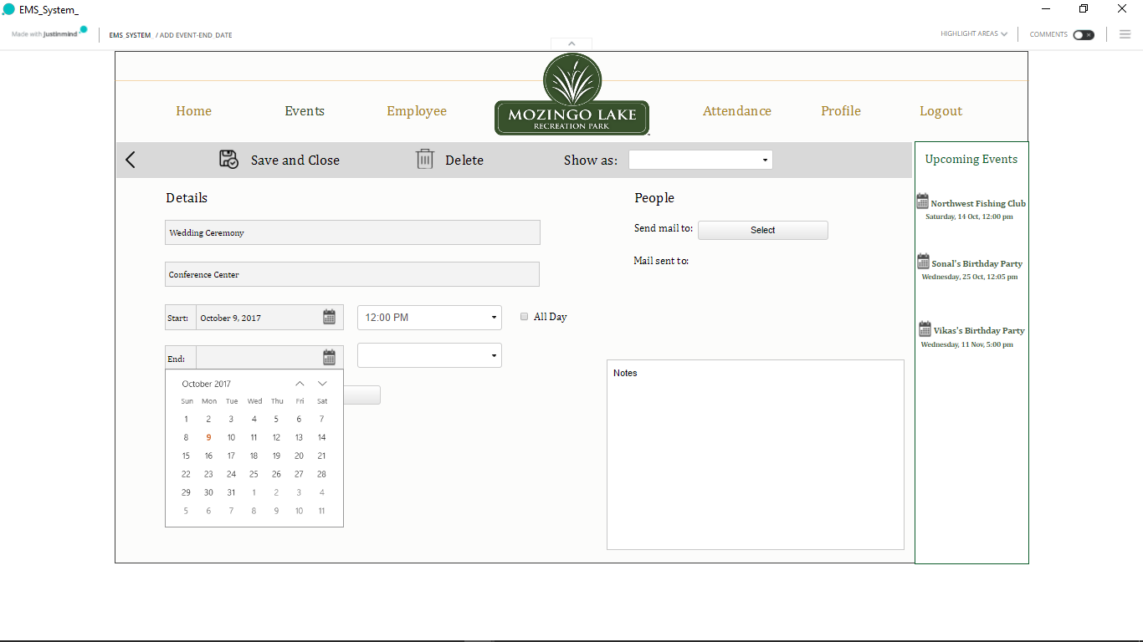

**Figure E2: Event Date selection**

User can set the start time and the end time of the event by clicking on the dropdown button, or if it is an all-day event there is a check box available named “All day” that can be selected. Notes can be added in the notes section available.

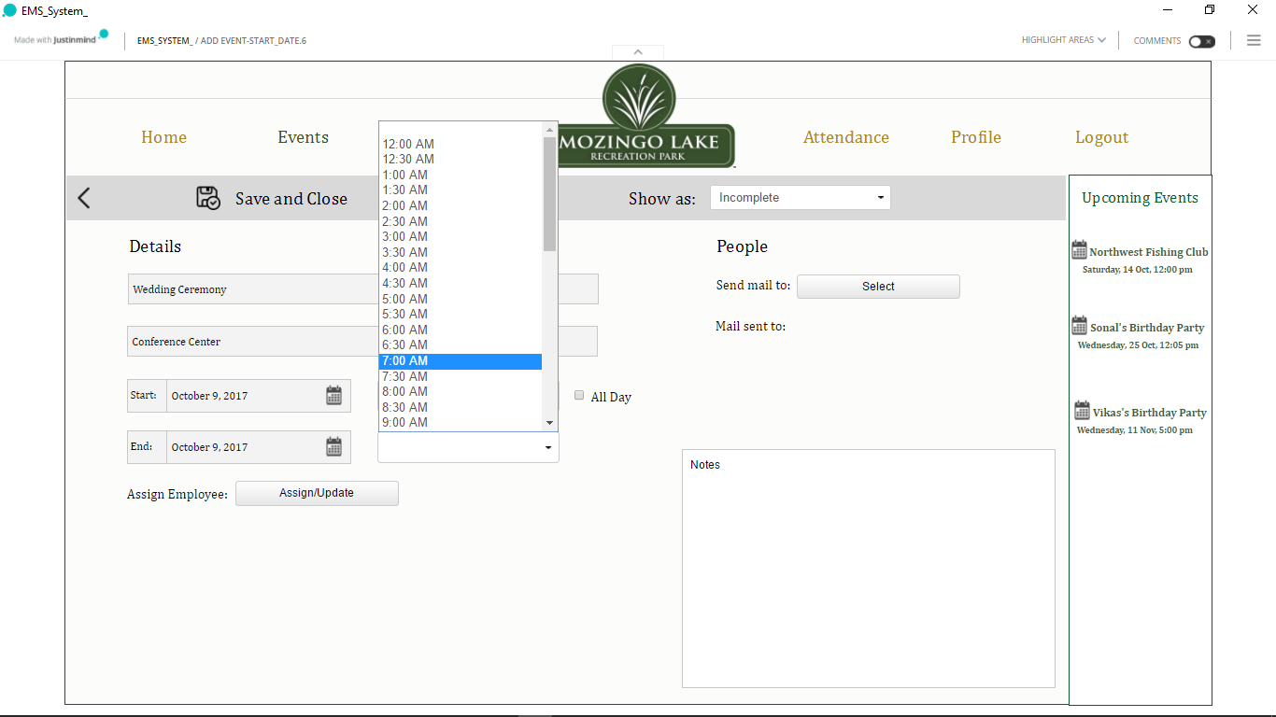

**Figure E3: Event Time selection**

Before assigning employees to an event user has an option to send E-mail to the employees (who may be part timer’s or full timer’s) to check their availability to work for the event. For this, User needs to click on the select button beside the label “Send mail to:” which then displays a window that shows the categories of employees that are “Assistant Coordinators, Bartenders, Maintenance and House-Keeping” with the list of employee’s names in them. User can select single or multiple employees from different categories, based on the requirement and click “Send E-mail” button. The employee names which are displayed in color “Red” indicate that the employee has already completed available limit of work hours for that week and hence cannot be selected. After selecting the available employees, the system will redirect the user to their E-Mail account from where the user can send a common E-mail to check their availability. User also has an option to “save and close” the window with the changes done till that point.

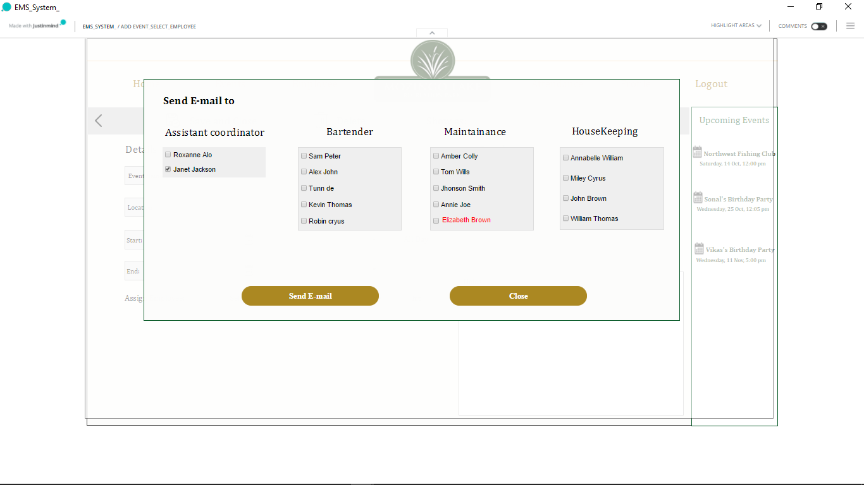

**Figure E4: Employee selection to send E-mail**

After the E-mail has been sent, user can view the list of employees displayed under “Mail sent to” to whom emails were sent.

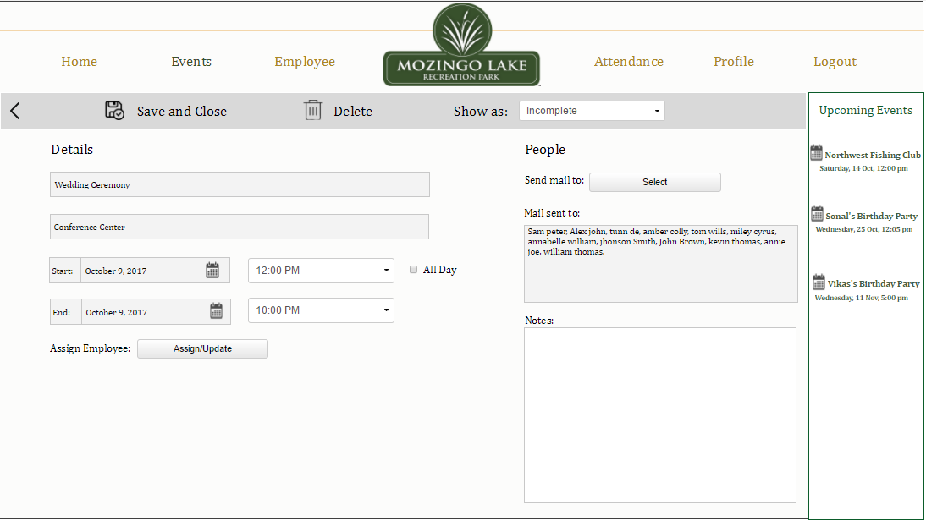

**Figure E5: Employee List to whom E-mails have been sent**

User can tag the event as incomplete to show that the event is partially scheduled and can save and close from the taskbar which displays the event name on the dashboard with a blue color tag assigned to it. Once the User gets the list of employees to assign the work for the event, they can click on the event name from the dashboard to make changes. To assign employees the user will have to click on the “Assign/Update” button which is available beside the “Assign Employee” Label. When the user clicks on this button, a window is displayed which again shows the categories of employees with employee names. User can select single or multiple employees and click on “Update” button to assign employees who have responded to the email by stating that that they are available to work. User also has an option to close the window if there are any unplanned changes.

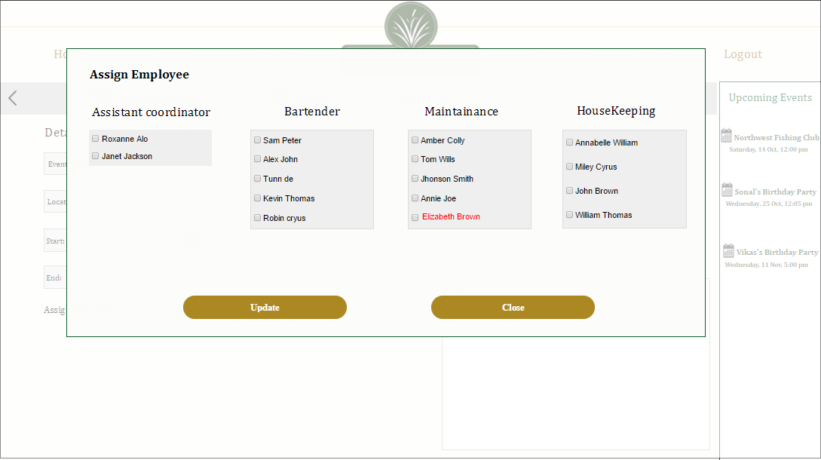

**Figure E6: Assigning employees to the event**

After clicking on “Update” button User gets the updated event view with the employee’s assigned to it. It displays the assigned employee name in different categories. User can allot hours by selecting the dropdown box and assign the Start Time and the End Time which consolidates the total number of hours that each employee has been assigned for that event. If any changes are needed to be made User can click on the “Assign/Update” button and make changes accordingly. User can delete the event if necessary by clicking on the delete button on the taskbar.

Ex: Assign hours to “Kevin”. Start time and End time i.e., 7:00pm to 9:00pm

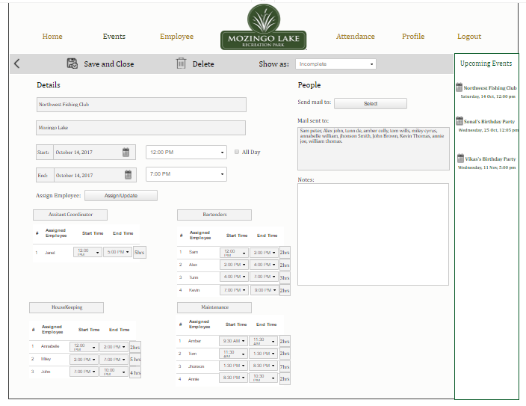

**Figure E7: Work hours allotment to assigned employees**

If user tries to allot more number of hours to an employee, a dialogue box appears warning the user that hours are exceeding the standard hours per week as shown in the image below. If the user clicks “ok” then the hours assigned is updated. If the user clicks “cancel” the system is redirected to work hours allotment page.

Ex: if user tries to assign more hours to Kevin, i.e., 7:00pm to 10:00pm instead of 7:00pm to 9:00pm. Dialogue box appears as shown below

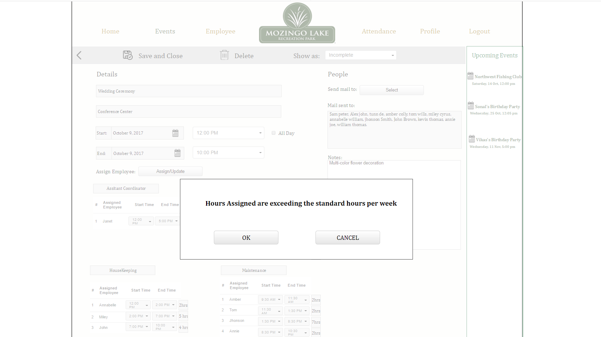

**Figure E8: Hours Exceed Dialogue Box**

If user clicks “OK” in the previous dialogue box, hours assigned gets updated as shown below, and if the user clicks on “CANCEL” timings will revert back to its original hours mentioned previously.

Ex: hours assigned to Kevin are updated to 7:00pm – 10:00pm

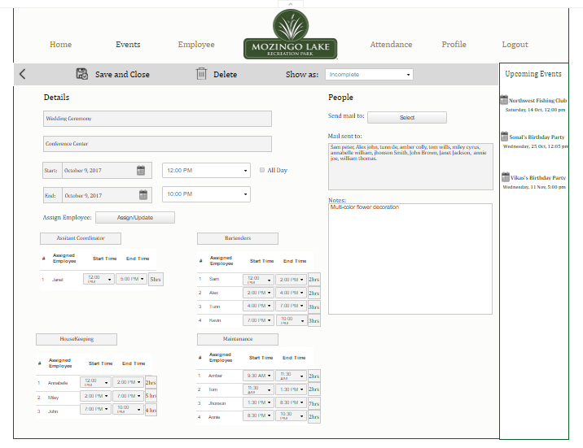

**Figure E9: Extra hours assigned**

There is also a back button available for User to go back to the dashboard without making any changes. Once all the details have been entered for the event, the user can set the tag to “Complete” and can click on “Save and Close”, and the dashboard will be updated with the event name and a green color tag assigned to it.

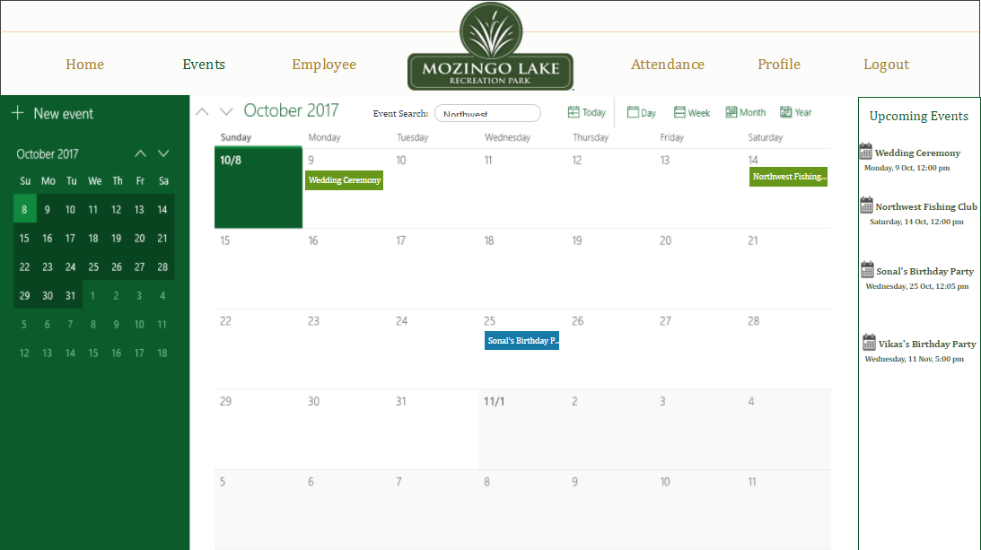

**Figure E10: Updated Dashboard**

When User wants to search an event from the search bar “Event Search”, User needs to type in the event name which they want to search, and press Enter key.



**Figure E11: Event Search**

When User presses the enter button, results with the names of the event are displayed if an event with that name exists.

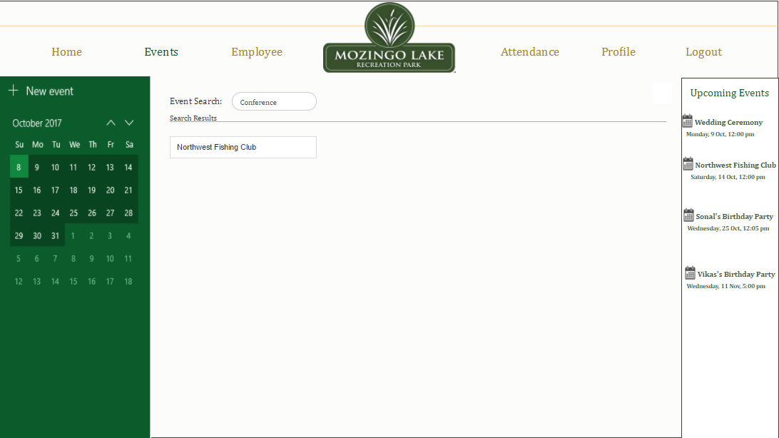

**Figure E12: Event Search Results**

If there are no results found with the name entered by the user (no such event exists), then “No event found” will be displayed. User can go “Back” to the dashboard to perform other actions.

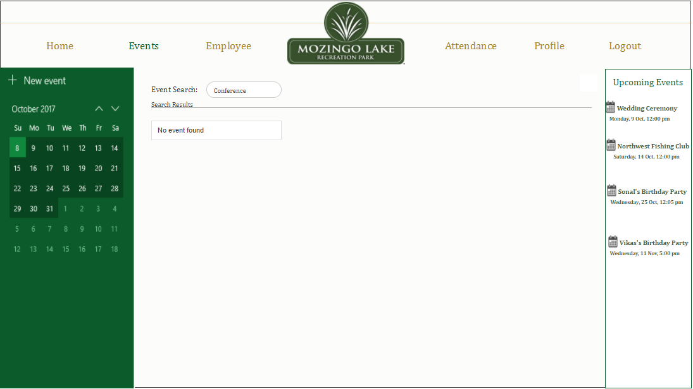

**Figure E13: Event Search Results Not Found**

When User wants to delete an event, User can click on the Delete option which is available on the taskbar. User will be prompted with a message saying, “Are you sure you want to delete the event?” with options “Yes” and “No”.

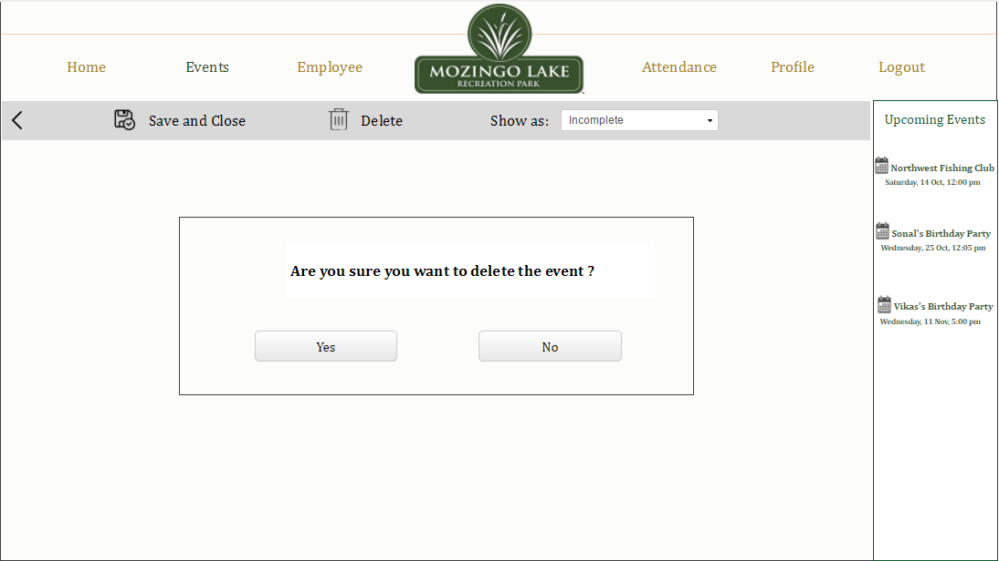

**Figure E14: Delete Event**

When User clicks “No”, User is redirected to the event details page. If User clicks “Yes”, a confirmation message saying, “Event Deleted Successfully” with an “OK” button is displayed. When User clicks on the “OK” button, user is redirected to the dashboard with the updated calendar.

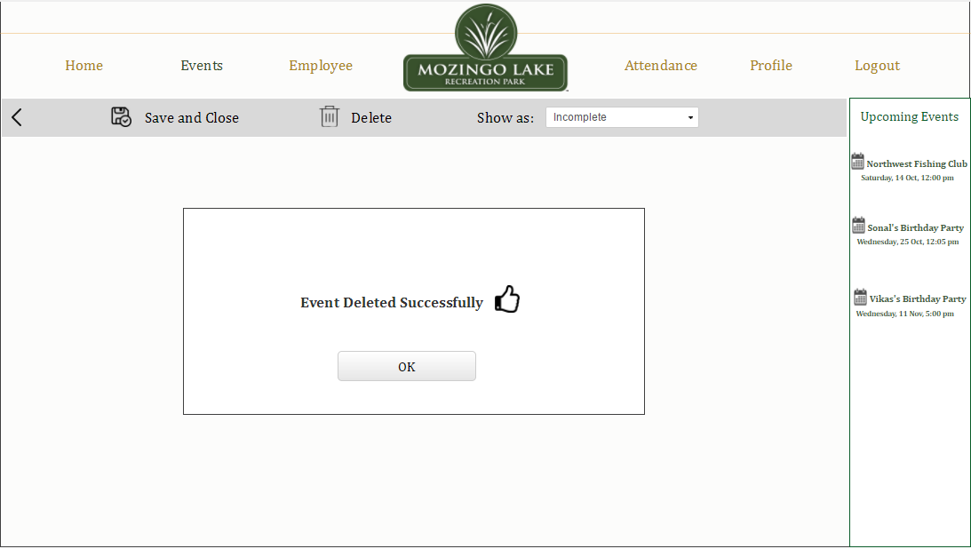

**Figure E15: Event Deleted**

## 6.6 Employee Tab

User can click on the Employee tab on the dashboard, which redirects him/her to the Employee catalog page, where user gets an option to either directly view all the list of employees or can use the “choose category” or “choose status” options to filter the list of available employees. Also, as we proceed we get to know about “delete” and “employee search” in this page. So, as we see the table below shows the name, employee id, category, email, and weekly hours, we can get more details of the employee by clicking on his name.

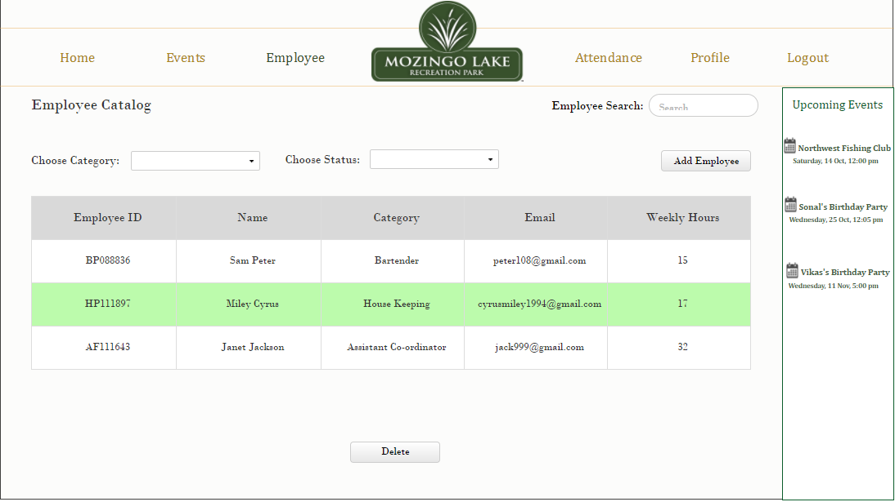

**Figure EM1: Employee Catalog**

When User clicks on the “Add Employee” button on the employee catalog page, the following page is displayed where the user can enter the details to add a new employee

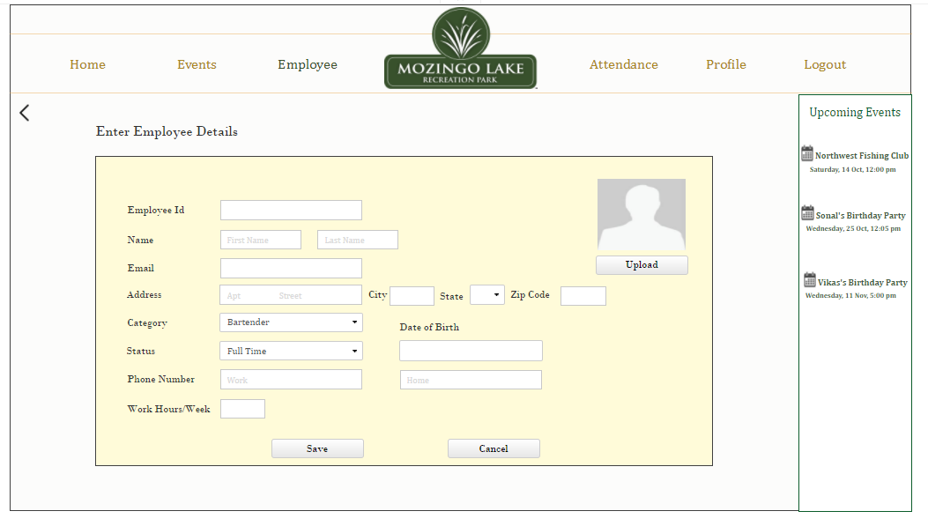

**Figure EM2: Add Employee**

As we proceed with entering the details of the new employee, all the details such as Name, Employee Id, Email, Address, Category, Status, Phone Number, Date of Birth and Work hours are supposed to be entered as shown below. A Profile Picture of the new employee can also be added.

Note: Employee ID begins with the first Letter of the Category and the Status to which an employee belongs followed by a dynamic number. Ex: The employee ID for a bartender who is a part time employee will have an ID starting with “B” (first letter of the category Bartender) followed by “P” (first letter of the employment status Part Time) followed by a number. Hence the employee id would be BPXXXX. This makes the administrator or anybody looking at the employee ID to easily detect the employee category and status,

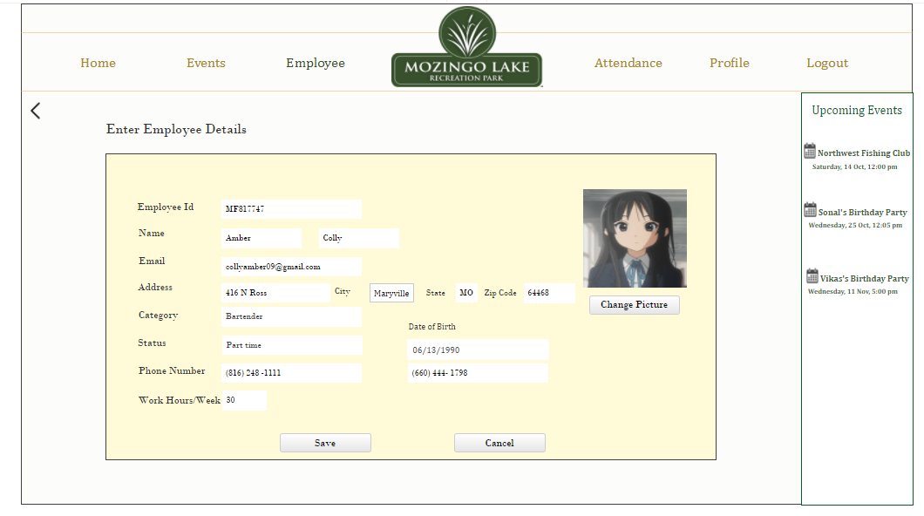

**Figure EM3: Employee Details**

Figure EM4 is the pop-up which comes whenever a user tries to use the back button without saving the changes when employee details are entered.

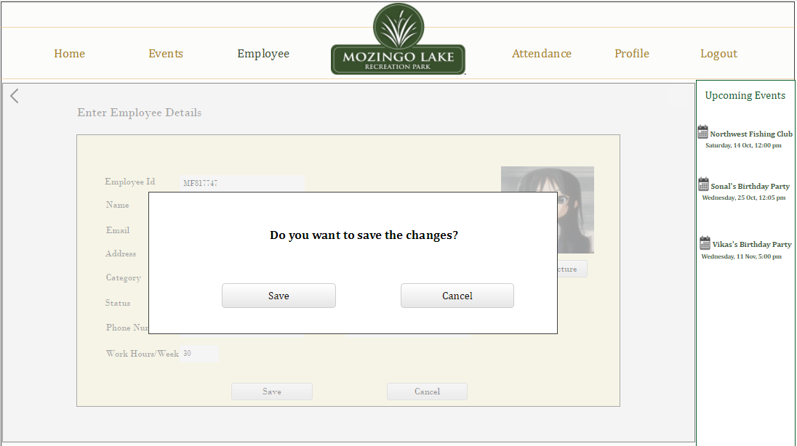

**Figure EM4: Save Changes Message**

After entering the details of an employee or by clicking on any employee name, User gets redirected to the following page. User can edit the current employee details in this page.

Ex: when the user clicks on Amber Colly in the consolidated view, the employee details are shown

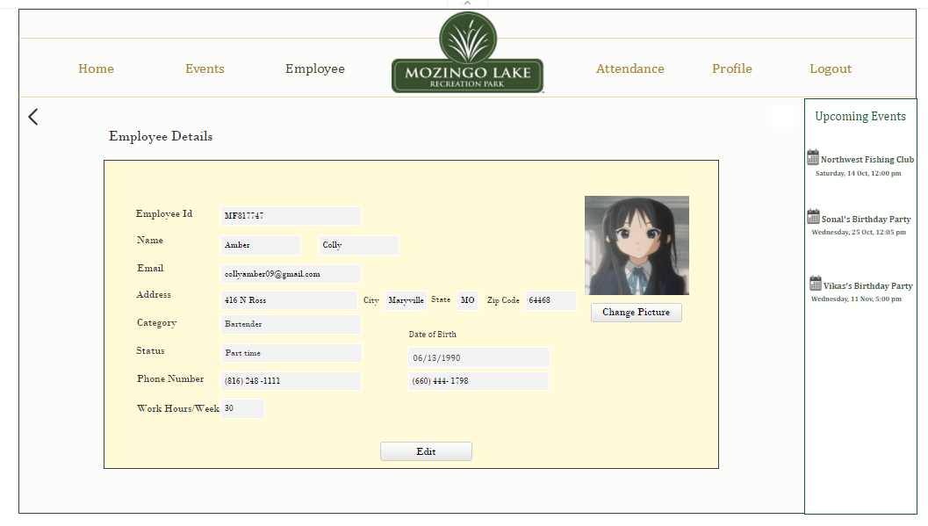

**Figure EM5: Show Employee Details**

When User wants to delete an employee from the list of current employees, they can simply select the employee who is to be deleted and then click on the delete button as shown in the given figure

Ex: Select Miley Cyrus to delete and then click on delete button

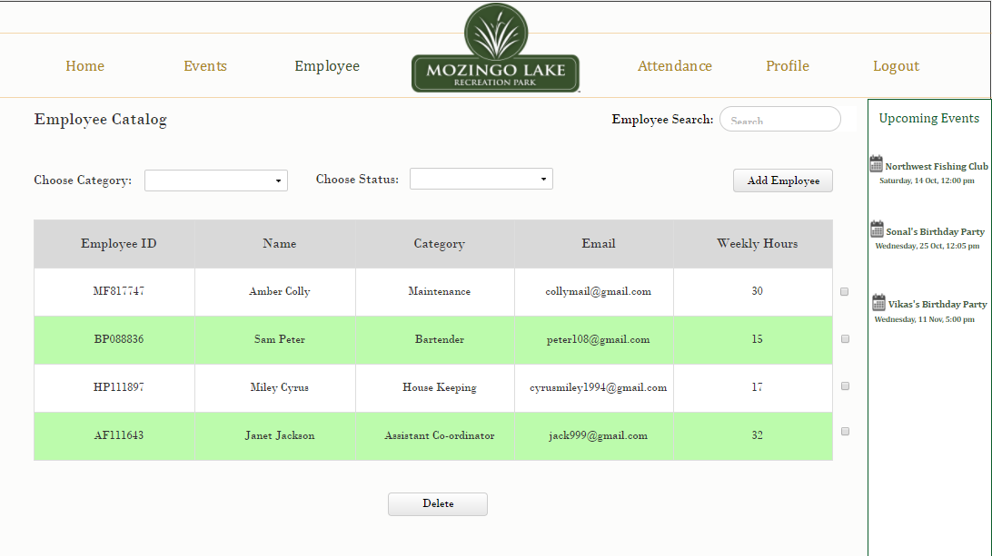

**Figure EM6: Delete Employee**

When User clicks on the Delete selected employee(s) button a confirmation message pops up as shown below. If User still wishes to delete the selected employee “Yes” needs to be selected.

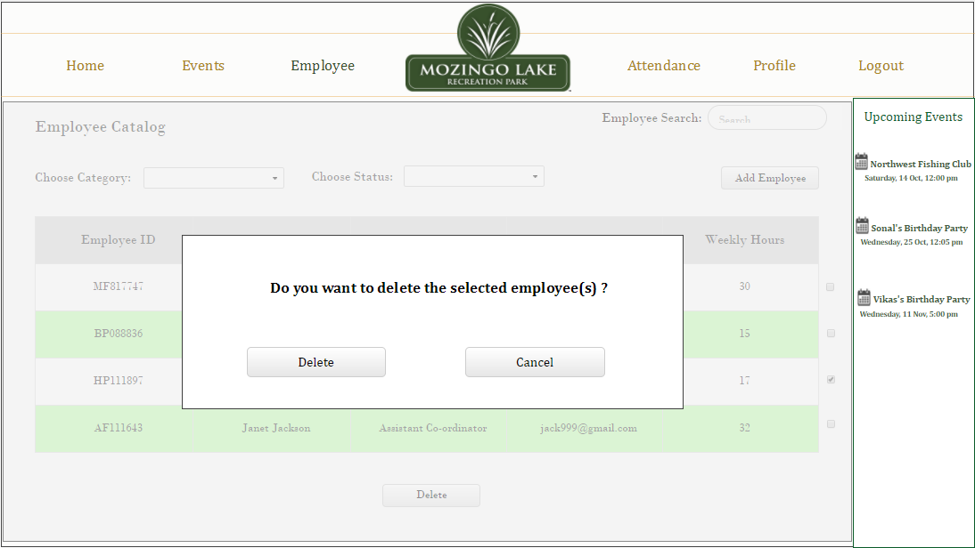

**Figure EM7: Delete pop-up**

Once the selected employees are successfully deleted, User is directed to the consolidated view where they can see a list of current employees which is the Employee Catalog

Ex: All details related to Miley Cyrus has been deleted.

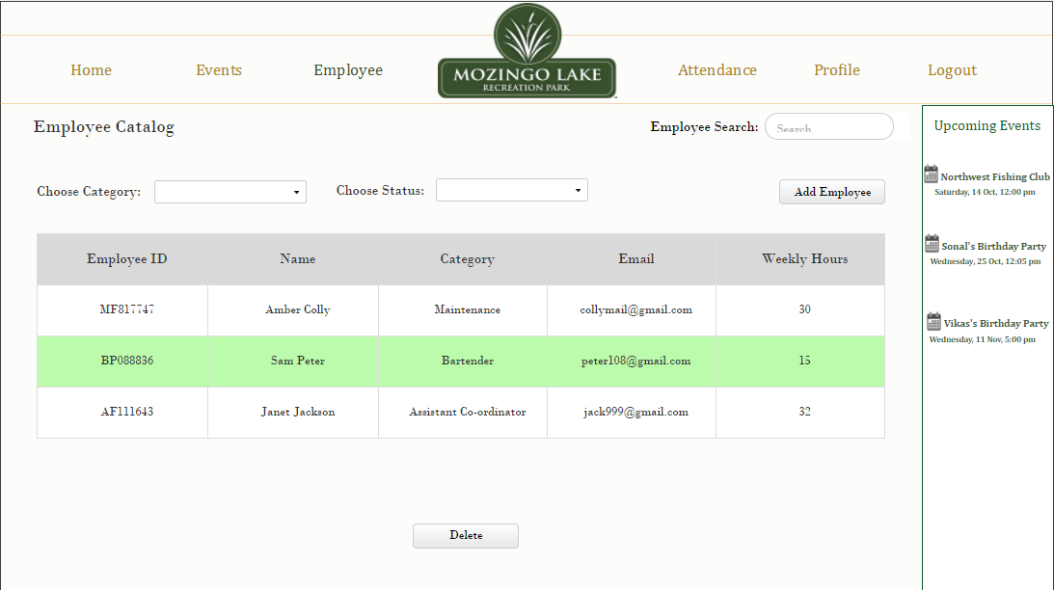

**Figure EM8: Employee Deleted**

User can search for employees by entering the name of the employee in the search bar. If the employee name exists in the current list of employees, then the list of employees with the same name is displayed

Ex: Search for employees named Sam and all the employees with the name Sam are displayed.

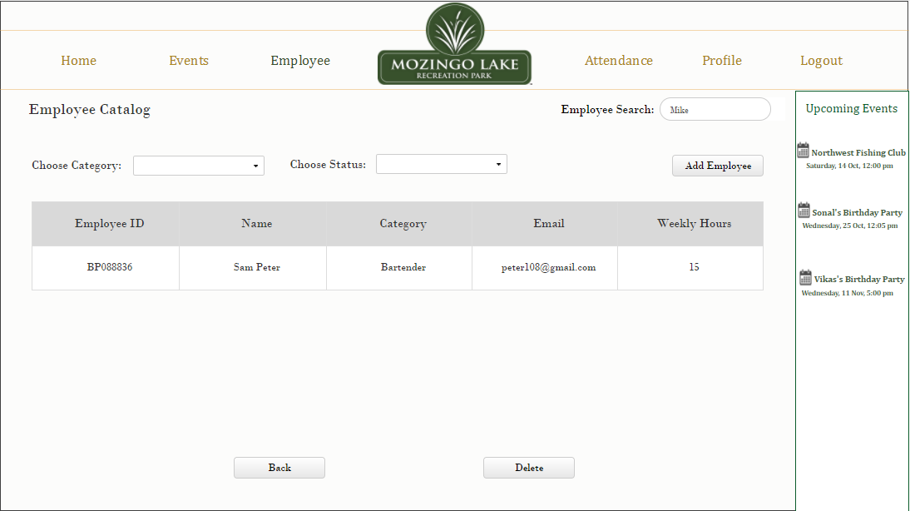

**Figure EM9: Employee Search**

If user searches for an employee who is not in the list of employees, then a message “No Results Found” is displayed as shown below. User can now go back to the Employee Catalog to perform a new search.

Ex: Search employee named mike results in no matches found.

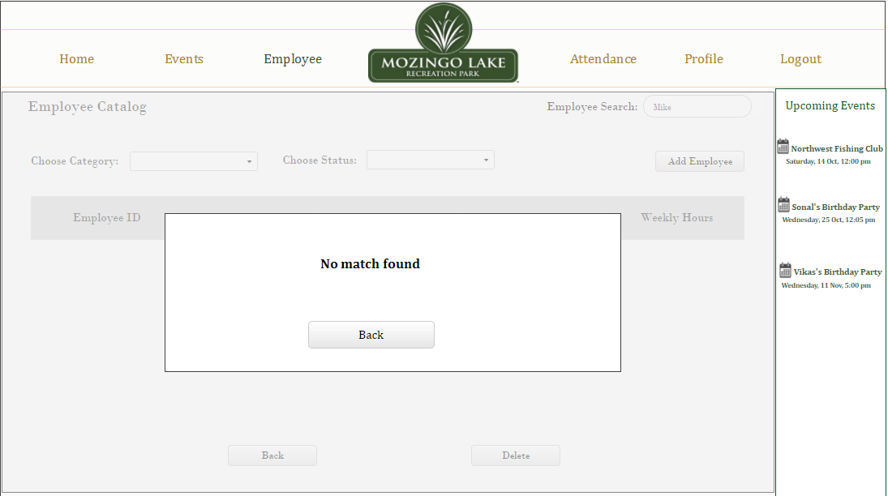

**Figure EM10: Employee not found**

## 6.7 Attendance Tab

The Attendance Tab provides information regarding an employee’s presence for an event, Leaves requested and Consolidated Reports that give an insight into an employee’s worked hours on a weekly and monthly basis. The functionality of each of the sub tabs that are present in the Attendance Tab i.e. Mark Attendance, Leave and Reports sub tabs are mentioned below:

### 6.7.1 Mark Attendance

The Mark Attendance sub tab is the default tab that would appear when a user clicks on the Attendance main tab. This gives a list of event names scheduled or completed according on monthly basis in ascending order. The current month appears in default which can be changed to a previous or next month as and when required by clicking on the arrow buttons mentioned before and after the Month respectively. It also shows the attendance status which can be complete or Incomplete. An incomplete status shows that the user has not marked attendance of at least one or all the employees who were assigned to an event. A complete status shows that the attendance has been marked for all the employees who were part of an event and the employee Reports, Events Tab has been updated with the hours remaining/ available for an employee to work.

Ex: Click on the event Wedding Ceremony to view attendance of all the employees assigned to that particular event

A screenshot of a social media post

Description generated with very high confidence

**Figure AM1: Mark Attendance Page**

To mark the attendance for an event, user can click on the required Event name, Date or Attendance Status after which user is directed to a page that contains the event name and the list of employees who were assigned to that event. This page also contains Hours Assigned which is the number of hours an employee was assigned work (This was done while scheduling the event from the events tab and assigning employees to it), the status of attendance that could be selected as Present, Absent or Partial. User can choose if the employee turned up for all the hours assigned, Absent if the employee did not turn up or Partial if the employee worked for only part of the assigned hours.

Ex: Mark the status of Tunn De as Partial as he/she has worked only part of the assigned hours.

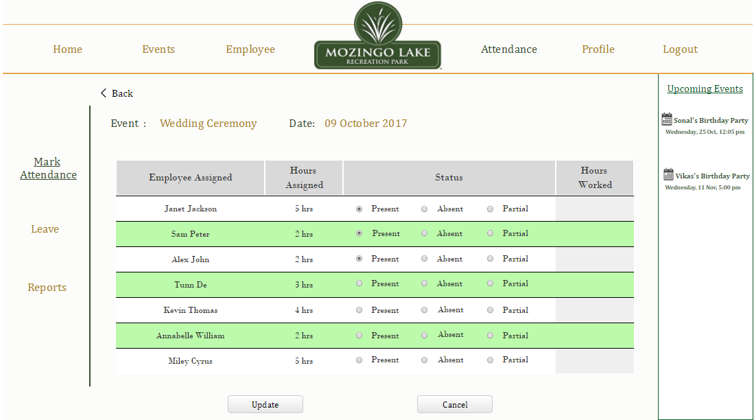

**Figure AM2: Mark Attendance for An Event**

If the employee worked for Partial Hours, The Hours Worked column is activated where user can enter the number of partial hours worked from the assigned hours for an employee. User needs to click on the update button to update the attendance.

A screenshot of a cell phone

Description generated with very high confidence

**Figure AM3: Assigning Partial Hours**

If the number or partial hours entered are more than the assigned hours, an error message is displayed when user is asked to re-enter correct hours which must be lower than the assigned hours.

A screenshot of a social media post

Description generated with very high confidence

**Figure AM4: Exceeded Assigned Hours**

After the required details are correctly selected for all the employees in the Mark Attendance Tab, when user click on the update button a message is displayed to save or cancel the changes made. When clicked on Save all the details are updated and the user is redirected back to the initial page with the Attendance Status shown as complete. Clicking on Cancel would terminate all the changes made. Based on the marked attendance the Events Tab and the Reports would get updated so that only the remaining hours can be scheduled for an employee for an event and the reports show the correct number of hours worked by an employee on weekly or monthly basis.

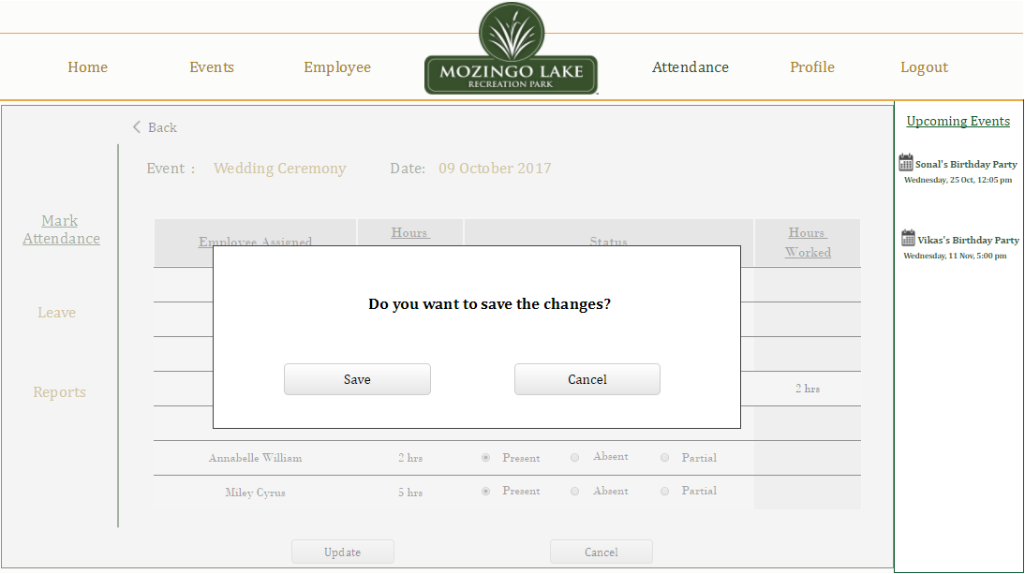

**Figure AM5: Attendance Update Changes Pop Up**

A screenshot of a social media post

Description generated with very high confidence

**Figure AM6: Attendance Status Complete**

### 6.7.2 Leave

Clicking on the Leave sub-tab, user can get a consolidated view of the list of employees who have requested for leaves in a month along with details regarding the leaves requested were Full Day or Half Day leaves. This page appears as below

A screenshot of a social media post

Description generated with very high confidence

**Figure AL1: Leave Page**

Whenever an employee requests for a leave via email or through word of mouth, User can add this request so that the details of employees who have requested leave on a day do not appear (the employee is disabled from selection) during assigning of employees to an Event in the events Tab. To do so User can click on the “Add Leave” button to add a leave. When user clicks on this button user is directed to a page where user needs to select Employee Type (Housekeeping, Bartender Etc.), Employee Name (which is filtered based on the selected employee type) and Leave type requested which would be a Half Day or Full Day Leave. Comments can also be updated to mark any special notes like reason for leave, Important updates etc.

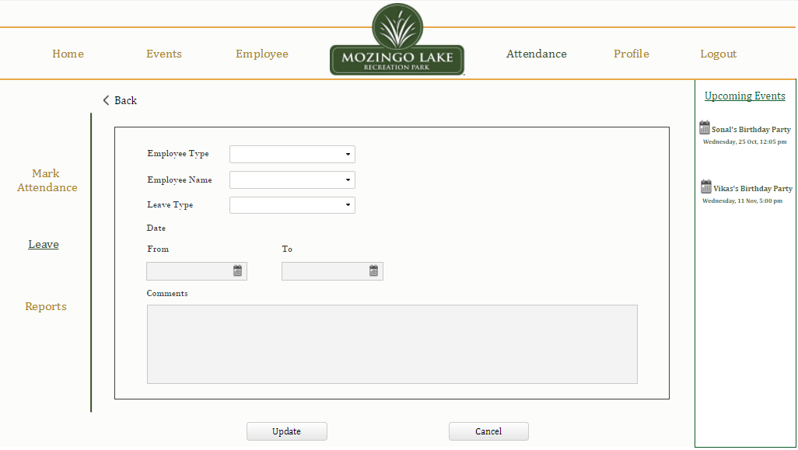

**Figure AL2: Leave Request**

When user selects the Leave Type as Half Day, the Date and Time categories are displayed where user can enter the From Date and the To Date would remain the same and can now enter the Timings of employee absence on the requested day. The Hours are automatically displayed when the Timings are selected.

A screenshot of a social media post

Description generated with very high confidence

**Figure AL3: Half Day Leave Request**

User can now click on the Update button to update the leave request. User is asked for a confirmation to save the changes requested. Clicking on Save will update the leave request and Cancel will terminate the action.

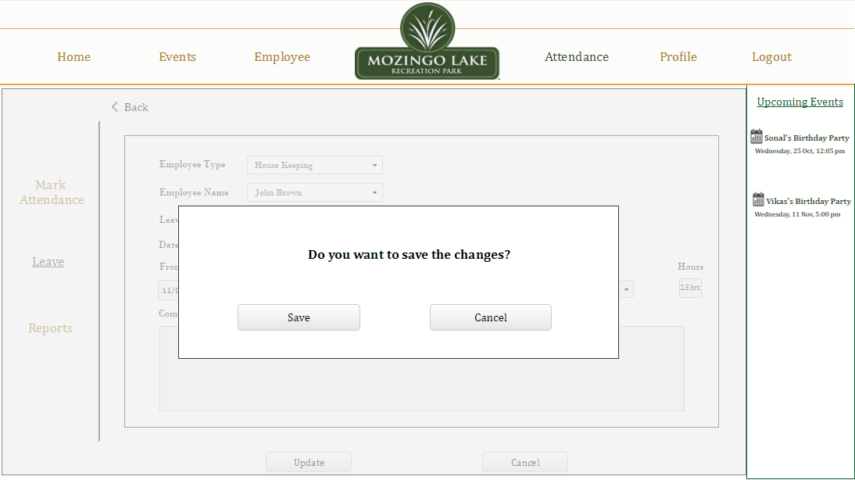

**Figure AL4: Leave Update Change Pop Up**

Once User clicks on Save the requested leave gets updated in the Consolidated Leave information displayed and Reports Sub-tab.

A screenshot of a social media post

Description generated with very high confidence

**Figure AL5: Leave Request Updated**

If User selects the leave type as Full Day, then the Time selection does not appear, and the user simply needs to select the dates for which the employee has requested for leaves and click on update to add the leave request. Editing the leaves requested can be done anytime by clicking on the employee name under the consolidated leaves page.

Ex: Click on Roxanne Alo to view or edit leave request details

A screenshot of a social media post

Description generated with very high confidence

**Figure AL6: Full Day Leave**

Note: If an employee requested for Full day leave, the Events Tab would have the employee name disabled from selection while assigning employees to the event scheduled on the requested leave date. Likewise, if an employee has requested for a half day leave, the requested time for the leave date would be disabled from selection and hours can be assigned for other timings.

User can also delete any added leaves by clicking on the Delete button. Whenever this button is clicked a selection appears where User can select single or multiple employee leave details to delete the request.

Ex: Select checkbox next to Roxanne Alo and delete the leave request

A screenshot of a social media post

Description generated with very high confidence

**Figure AL7: Leave Delete Request**

When User clicks on the “Delete” button after selection, a pop-up appears to confirm the deletion or cancel. Clicking on delete will delete the selection and the updated list is displayed.

A screenshot of a social media post

Description generated with very high confidence

**Figure AL8: Delete Request** **Pop Up**

A screenshot of a social media post

Description generated with very high confidence

**Figure AL9: Leave Page Updated**

### 6.7.3 Reports

The Reports Sub-Tab provides information on weekly and Monthly basis of all the employees who worked for that period with information pertaining the Employee ID, Employee Name, Standard Hours/Week (the number of default hours they are allowed to work), Worked Hours/Week and Leaves Taken (Hours/Days) if any and overtime Hours. Overtime hours are the number of hours that an employee works more than the standard hours allotted to the employee weekly/monthly. The information provided here is based on descending order of the number of hours worked i.e. an employee who worked for maximum hours in a week is displayed first followed by others in descending order. In this way the user looking for reports need not scroll longer and may not require information of employees who did not work in the week. This information gets updated every time the employee attendance is marked, and the leaves are added in the Mark Attendance and Leave sub-tabs respectively. This information can be printed by clicking on the Print button. An example of a weekly report is shown below.

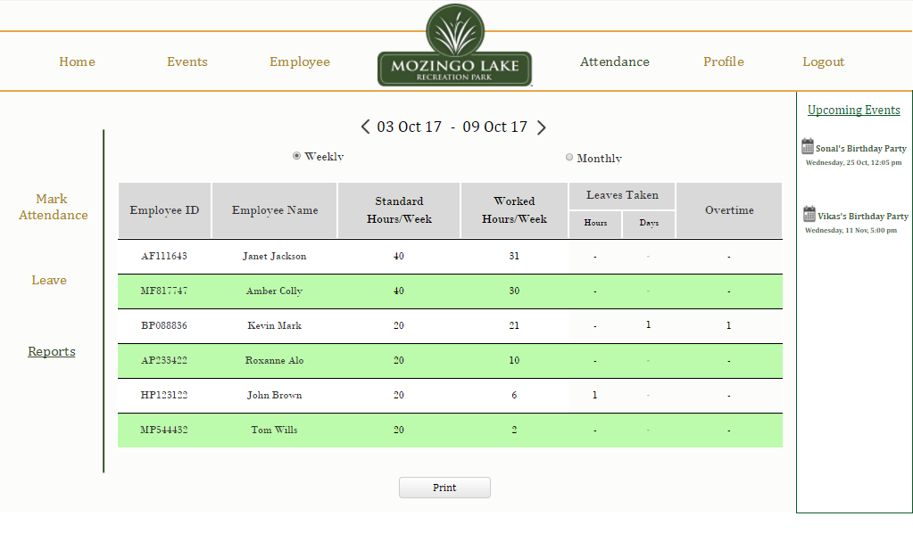

**Figure AR1: Weekly Report**

A monthly report of all the employees and their work hours can also be seen by selecting the “Monthly” radio button. A Monthly report would look something as shown below.

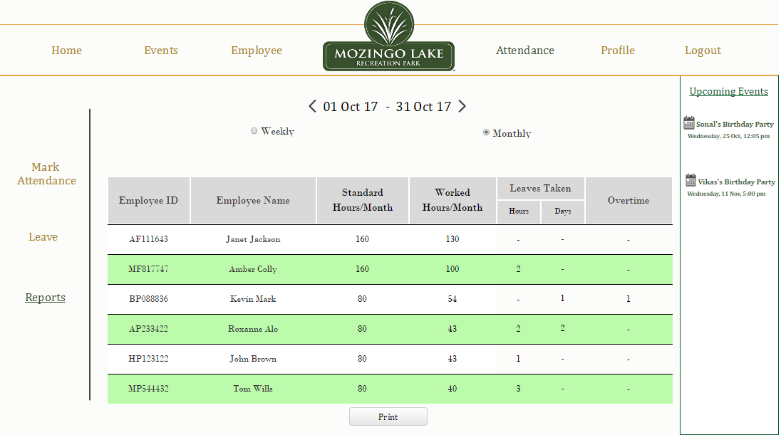

**Figure AR2: Monthly Report**

If User requires further detailed information/report regarding a particular employee, User can click on the Employee Name and a new page appears which consists of detailed employee information for the selected week/ month like the Date, Time In – Time Out (Timings assigned), Hours worked and Status which displays whether the employee was Present, Absent, Partially Present or applied for a leave on a particular date. This information is updated every time based on the information updated in the Events Tab and the attendance, leaves marked in the Mark Attendance and Leave sub-tabs respectively. This information can be printed by the user to match or compare the company’s employee time sheet to check if the hours were correctly recorded. An example of a detailed weekly report for an employee is shown below.

Ex: Click on Kevin Mark to view his weekly/monthly reports

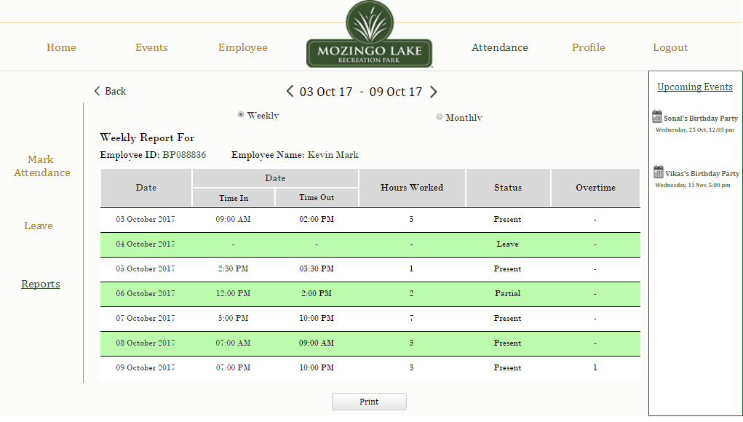

**Figure AR3: Detailed Report**

## 6.8 Logout Page

Super User will be able to Log Out of the system by clicking on the “Log Out” option provided in the dropdown list of “Welcome Username” on the top right of the screen.

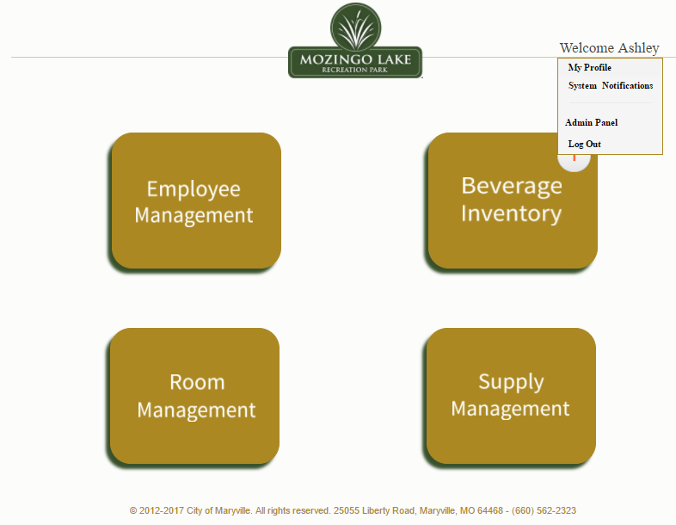

**Figure LO1: Logout From Homepage**

If the user clicks on “Logout” option in the user homepage or anywhere in the internal system, the user will be logged out and will be provided an option to re-login if the user wishes to do so.

A screenshot of a social media post

Description generated with very high confidence

**Figure LO2: User Logout**